
INDUSTRY REPORT
Merchant Banking Services in the US
Dec 2025

About

IBISWorld
IBISWorld specializes in industry research with coverage on thousands of global industries. Our comprehensive data and in-depth analysis help businesses of all types gain quick and actionable insights on industries around the world. Busy professionals can spend less time researching and preparing for meetings, and more time focused on making strategic business decisions.

Table Of Contents | Standard

1. About 4
Codes 4
Definition 4
Related Terms 4
What's Included 4
Companies 4
Related Industries 5
Additional Resources 5
2. At a Glance 6
Key Takeaways 6
Products and Services 7
Major Players 8
Key External Drivers 9
Industry Structure 9
SWOT 10
Executive Summary 10
3. Performance 11
Highlights 11
Key Takeaways 11
Performance Snapshot 12
Outlook 20
Life Cycle 22
4. Products and Markets 23
Key Takeaways 23
Products and Services 23
Major Markets 27
International Trade 30
5. Geographic Breakdown 31
Key Takeaways 31
Business Locations 32
6. Competitive Forces 37
Key Takeaways 37
Concentration 37
Barriers to Entry 38
Substitutes 39
Buyer & Supplier Power 41
7. Companies 43
Key Takeaways 43
Market Share 44
Companies 45
8. External Environment 52
Key Takeaways 52
External Drivers 52
Regulation & Policy 55
Assistance 56
9. Financial Benchmarks 57
Key Takeaways 57
Cost Structure 57
Financial Ratios 61
Key Ratios 66
10. Key Statistics 68
Industry Data 68

1. About
https://my.ibisworld.com/us/en/industry/OD6088/about

Codes
NAICS 2017 - USA | 523110
NAICS 2022 - USA | 523150

Definition
This industry primarily makes private equity investments with firm or investor capital into the securities of private or public companies. It also provides a wide range of ancillary bridge, mezzanine, real estate and distressed financing as well as international trade financing and foreign direct investment services in varying degrees. This industry is a segment of the Investment Banking and Securities Dealing industry (IBISWorld report 52311).

Related Terms

UNDERWRITING
Raising investment capital from investors on behalf of corporations that are issuing securities.

BRIDGE FINANCING
Typically a short-term method of financing a company's operations prior to its initial public offering.

MEZZANINE FINANCING
Debt capital that affords the lender the right to convert to an equity interest in a company if they do not pay back their loan in time or in full.

What's Included
- Providing equity financing
- Providing bridge and mezzanine financing
- Providing trade financing
- Providing international transaction facilitation services

Companies
- The Goldman Sachs Group, Inc.
- Jpmorgan Chase & Co
- Bank Of America Corporation

Related Industries

Industries in the Same Sector
- Competitors:
  - Securities Brokering in the US
  - Private Equity, Hedge Funds & Investment Vehicles in the US
- Complementors:
  - Commercial Banking in the US
  - Investment Banking & Securities Dealing in the US

International Industries
- Investment Banking & Securities Brokerage in Australia
- Security & Commodity Contracts Brokerage in the UK
- Securities Investment in China

Additional Resources
- Securities Industry & Financial Markets Association
- The US Federal Reserve
- Federal Deposit Insurance Corporation

2. At a Glance
https://my.ibisworld.com/us/en/industry/OD6088/at-a-glance
Revenue  $15.4bn  ’20-’25 ↑ 7.0 %  ’25-’30 ↑ 1.6 % | Employees  16,022  ’20-’25 ↑ 6.1 %  ’25-’30 ↑ 3.2 % | Businesses  680  ’20-’25 ↑ 6.0 %  ’25-’30 ↑ 6.0 %
Profit  $5.2bn  ’20-’25 ↑ 5.4 % | Profit Margin  33.7%  ’20-’25 ↓ 2.5 pp | Wages  $7.0bn  ’20-’25 ↑ 8.4 %  ’25-’30 ↑ 2.9 %

Key Takeaways

Performance
- Declines in initial public offerings limit revenue growth. Because merchant banks earn revenue from the eventual sale of their equity investments in middle-market companies, as IPOs slowed, companies subsequently earned less from equity investments, limiting industry revenue growth during the period.
- Resurgent public equity markets have benefited merchant banks. This indicates health in the economy that is reflected in favorable yields for private capital investments for merchant banks.

Products and Markets
- Merchant banks advise clients and invest alongside them. These banks have traditionally operated internationally, providing services like foreign corporate investing, trade financing and international transaction facilitation services.
- Merchant banks bridge the gap of private equity and venture capital. Their clients are generally unlisted middle-market firms seeking equity and debt financing and advisory services.

Products and Services
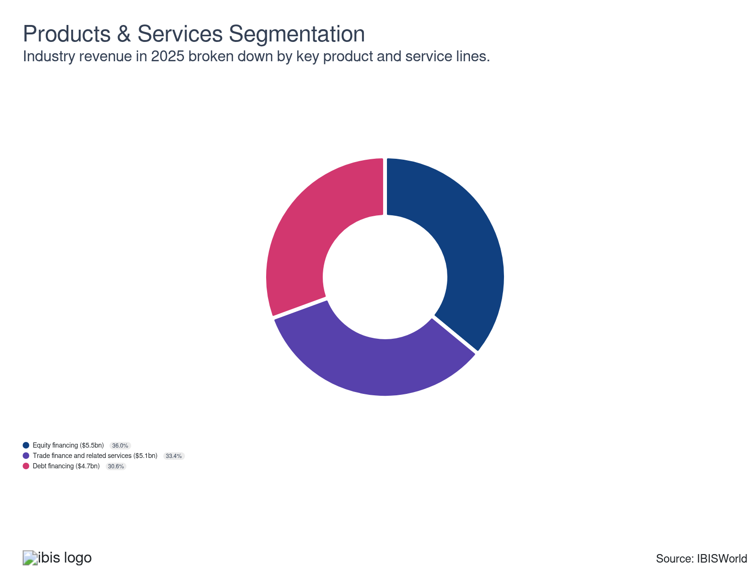

Major Players
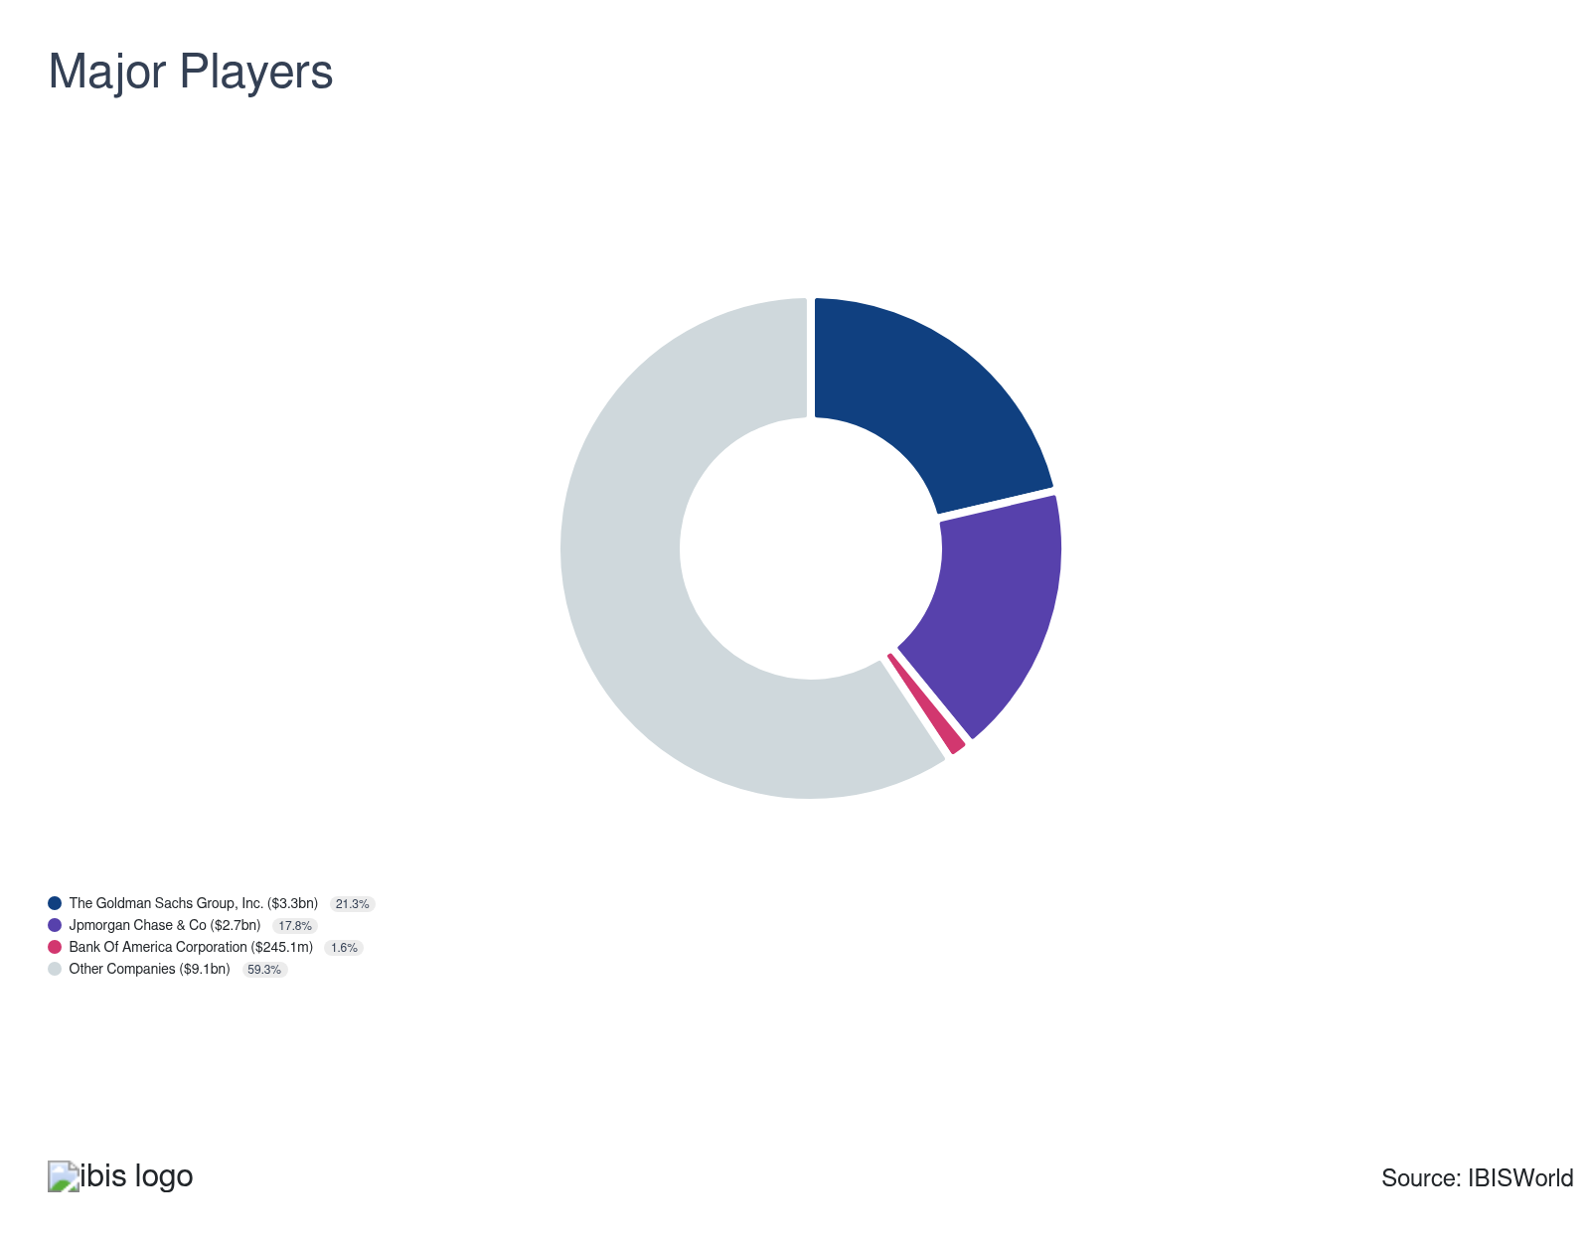

Key External Drivers
Key External Drivers | Impact
Prime rate | Positive
Access to credit | Positive
Initial public offerings | Positive
Total trade value | Positive

Industry Structure
Characteristic | Level | Trend
Concentration | Moderate
Barriers To Entry | Moderate | Increasing
Regulation and Policy | Moderate | Increasing
Life Cycle | Mature
Revenue Volatility | Moderate
Assistance | Low | Steady
Competition | Moderate | Increasing
Innovation | Moderate

SWOT
Strengths  Medium & Increasing Barriers to Entry  Low Imports  High Profit vs. Sector Average  Low Product/Service Concentration  Low Capital Requirements | Weaknesses  Low & Steady Level of Assistance  High Customer Class Concentration | Opportunities  High Revenue Growth (2020-2025)  High Revenue Growth (2025-2030)  Access to credit | Threats  Very Low Revenue Growth (2005-2025)  Low Outlier Growth  Low Performance Drivers  Initial public offerings

Executive Summary

Good investment: Increased private capital investment and financial market yields will benefit merchant banks
The industry experienced moderate growth during the period. Merchant banks provide equity, debt and trade financing to middle-market private companies. Merchant banks often invest in the debt of private companies through mezzanine financing and senior loans. Regarding trade financing, merchant banks provide foreign corporate investment and international transaction facilitation services. Merchant banks also offer lines of credit and issue letters of credit between importers and exporters. While large financial holding companies, like The Goldman Sachs Group Inc. (Goldman Sachs), have merchant banking segments or subsidiaries, most merchant banks are relatively small and specialized, with the average enterprise employing about 21 individuals. Overall, industry revenue has grown at a CAGR of 6.9% to $15.4 billion over the past five years, including an anticipated increase of 3.3% in 2025 alone. However, profit is expected to lag to 33.7% of revenue in the current year, down from 36.2% in 2020.
A significant portion of merchant banking activity involves providing equity financing to private, middle-market companies and offering short-term bridge financing to companies prior to an initial public offering (IPO). While decreases in IPOs do not directly damage industry revenue, they reduce demand for bridge financing. However, amid rising equity markets, the equity investments of merchant banks yield higher returns in the event of an IPO. Rising equity markets and increases in IPO volume in the latter part of the period will contribute to higher yields on merchant banks' equity investments and greater demand for bridge financing provided by merchant banks.
During the outlook period, as an alternative to expensive equity financing and rigid senior loans, flexible, affordable mezzanine financing will continue to grow in popularity. Mezzanine financing also produces higher yields on average than other forms of funding, which will boost industry revenue growth during the outlook period. Increases in initial public offerings will drive demand for bridge financing. Industry revenue is forecast to increase at a CAGR of 1.6% to $16.7 billion over the five years to 2030.

3. Performance
https://my.ibisworld.com/us/en/industry/OD6088/performance

Highlights
Revenue  $15.4bn  2020-25 CAGR ↑ 7.0 %  2025-30 CAGR ↑ 1.6 % | Employees  16,022  2020-25 CAGR ↑ 6.1 %  2025-30 CAGR ↑ 3.2 % | Businesses  680  2020-25 CAGR ↑ 6.0 %  2025-30 CAGR ↑ 6.0 %
Profit  $5.2bn  2020-25 CAGR ↑ 5.4 % | Profit Margin  33.7%  2020-25 CAGR ↓ 2.5 pp

Key Takeaways
- Declines in initial public offerings limit revenue growth. Because merchant banks earn revenue from the eventual sale of their equity investments in middle-market companies, as IPOs slowed, companies subsequently earned less from equity investments, limiting industry revenue growth during the period.
- Resurgent public equity markets have benefited merchant banks. This indicates health in the economy that is reflected in favorable yields for private capital investments for merchant banks.

Performance Snapshot
Revenue: | ↑ 2020-25 Revenue CAGR +7.0%
Revenue  $15.4bn  ’20-’25 ↑ 7.0 %  ’25-’30 ↑ 1.6 % | 2025 Revenue Growth  ↑ 3.3 % | Revenue Volatility  Moderate
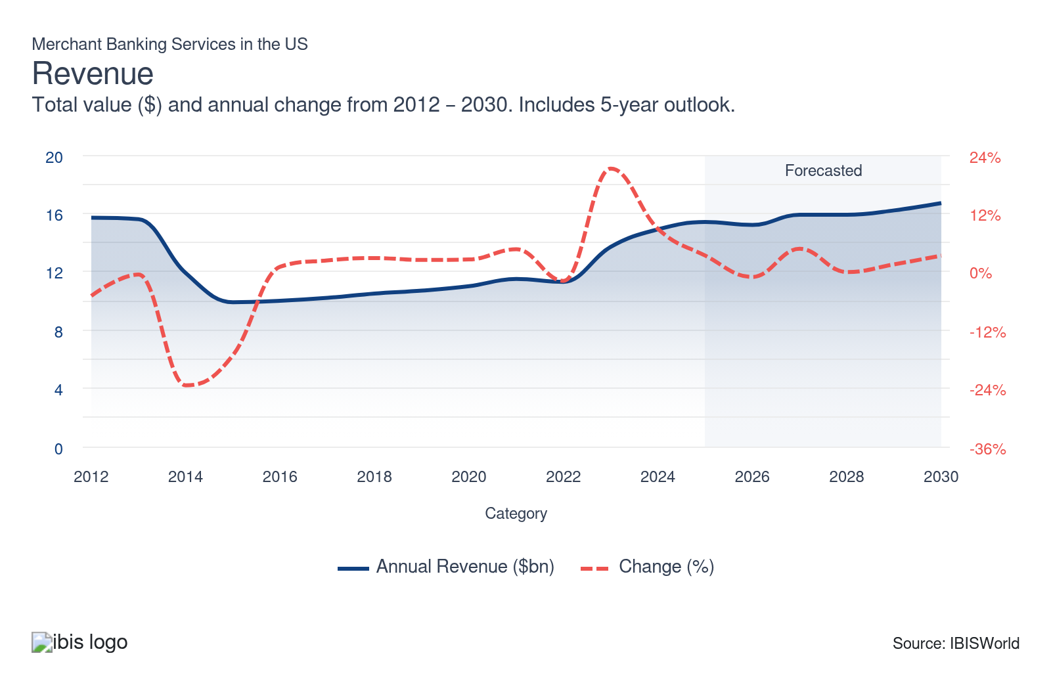
Employees: | ↑ 2020-25 Employees CAGR +6.1%
Employees  16,022  ’20-’25 ↑ 6.1 %  ’25-’30 ↑ 3.2 % | Employees per Business  24  ’20-’25 ↑ 0.1 %  ’25-’30 ↓ 2.7 % | Revenue per Employee  $961k  ’20-’25 ↑ 0.8 %  ’25-’30 ↓ 1.5 %
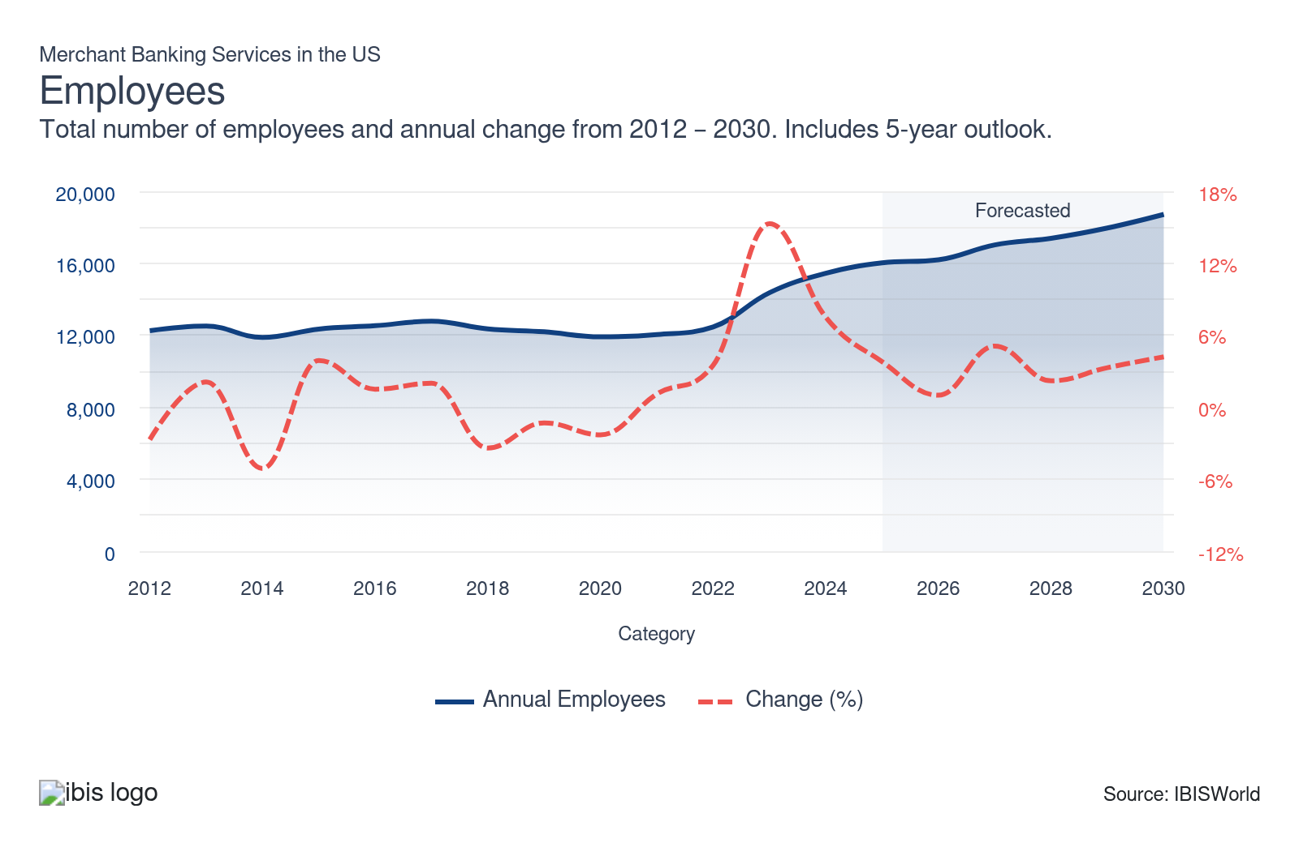
Businesses: | ↑ 2020-25 Business CAGR +6.0%
Businesses  680  ’20-’25 ↑ 6.0 %  ’25-’30 ↑ 6.0 % | Employees per Business  24  ’20-’25 ↑ 0.1 %  ’25-’30 ↓ 2.7 % | Revenue per Business  $22.6m  ’20-’25 ↑ 0.9 %  ’25-’30 ↓ 4.1 %
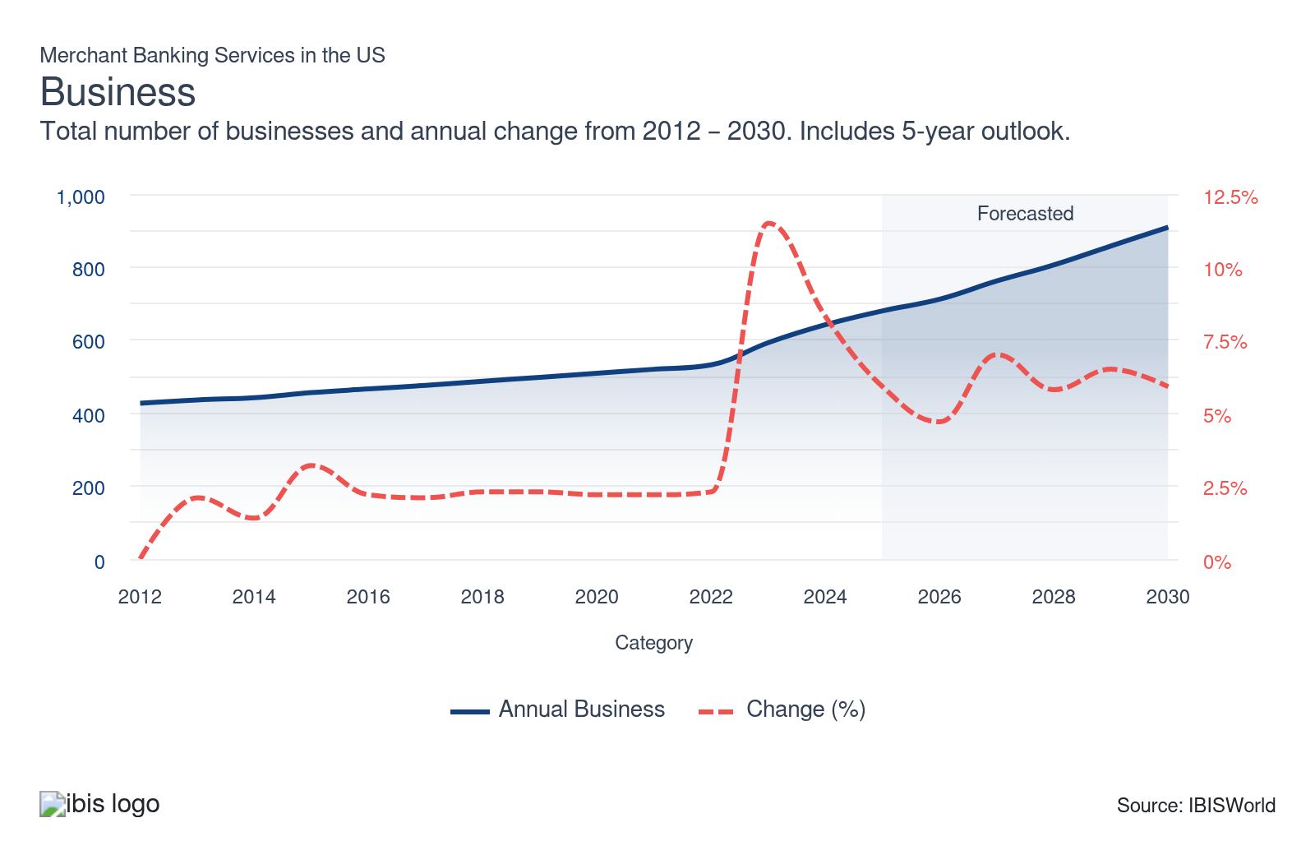
Profit: | ↑ 2020-25 Profit CAGR +5.4%
Total Profit  $5.2bn  ’20-’25 ↑ 5.4 % | Profit Margin  33.7%  ’20-’25 ↓ 2.5 pp | Profit per Business  $7.6m
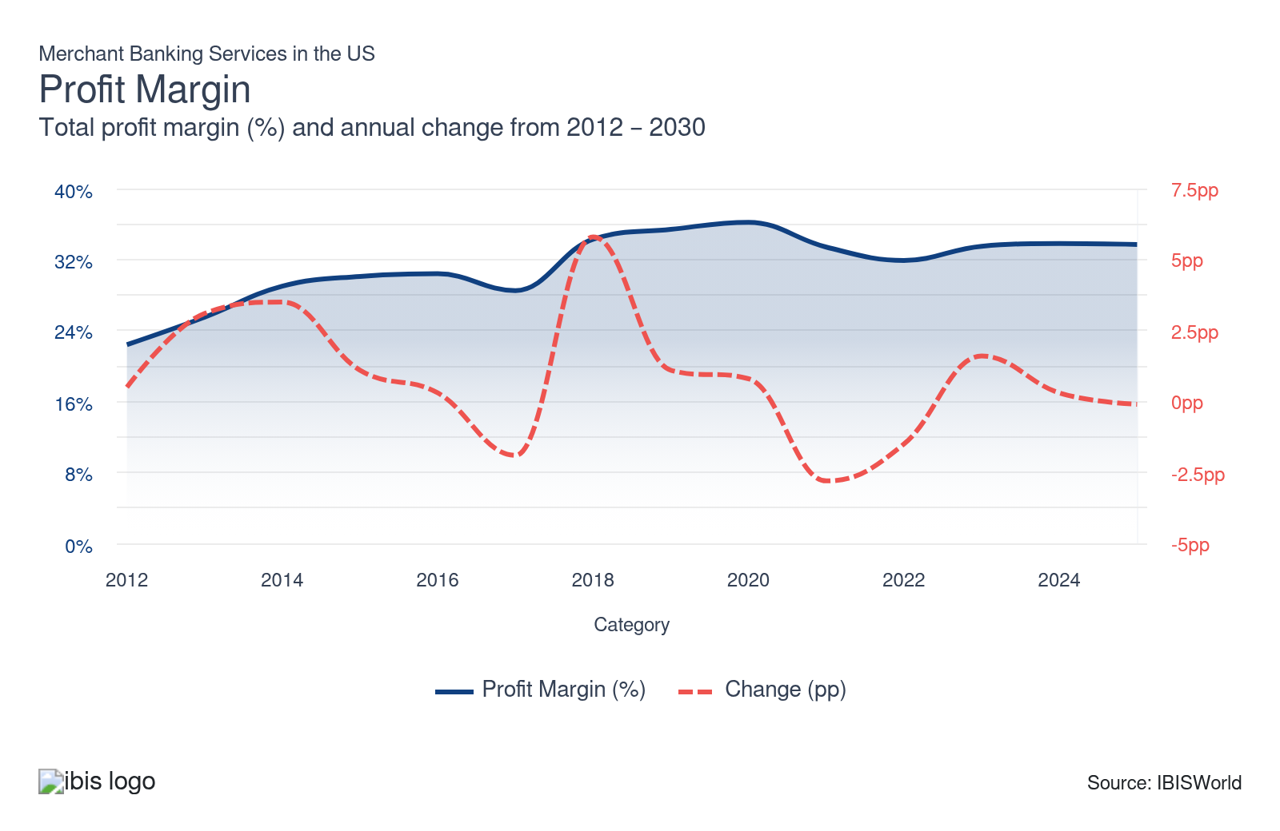
Current Performance
Current Performance

What's driving current industry performance?

The industry will expand as demand for industry services swell
- Merchant bank services vary significantly in terms of product focus and size. Larger players have greater scale and can serve various clients and regions. In addition to traditional merchant banking services, like trade financing, international transaction facilitation services and providing letters of credit and trade consulting, merchant banks also invest in the equity and debt of private companies.
- Numerous merchant banks entered the industry, seeking to connect customers looking for private capital with their funds and outside investors' capital. By facilitating these connections, merchant banks provide vital financial support, enabling businesses to access a diverse range of funding sources and drive growth.
- As a result, the number of industry enterprises increased along with industry employment to meet the growing demand for trade financing solutions and the expanding number of equity and debt investment opportunities. The growing demand for industry services was fueled by the growing need for clients who experienced growth in valuations and rising corporate profit.

Traditional product trends make a comeback
- Trade financing primarily involves facilitating international trade, like financing global expansion and issuing letters of credit between importers and exporters. International transaction facilitation takes on a crucial advisory role. Merchant banks that provide these services focus on the costs of moving goods across borders and often take on the risk associated with these transactions.
- The revenue share from Pacific Rim clients has consistently grown in recent years, particularly regarding trade facilitation services. As the total trade value increases, trends related to trade facilitation services will continue to drive revenue growth for the industry. However, total trade value growth was limited in the latter part of the period due to rising trade tensions and the potential of tariffs being placed on trading nations.
- According to the United Nations Economic and Social Commission for Asia and the Pacific, Singapore, Japan and South Korea have led the way with the implementation of trade facilitation measures. This progress creates significant opportunities for merchant banks, allowing them to enhance their trade finance services.

Mezzanine financing drives expansion despite IPO activity declining
- The decline in initial public offerings (IPOs) placed downward pressure on revenue from merchant banks' equity investments and limiting the industry's revenue from bridge financing. While merchant banks do not generate revenue from IPOs, operators indirectly receive fees from bridge financing, therefore, when initial public offerings decrease, merchant banks experience a decrease in bridge financing.
- At the onset of the period, when interest rates were at record lows, initial public offerings climbed, skyrocketing 68.9% and 82.1% in 2020 and 2021, respectively. However, the Fed raised interest rates substantially to tackle rampant inflation, hindering the IPO market. IPOs fell drastically in 2022, falling 94.6%. As inflationary pressures eased and the Fed slashed rates, the IPO market somewhat rebounded in the latter part of the period.
- Under mezzanine financing arrangements, the merchant bank receives the right to convert to an equity interest in the company if the loan is not paid back on time or in whole. The growth of mezzanine financing and climbing equity markets helped support substantial industry revenue growth. The S&P 500 climbed significantly during the period, boosting demand for mezzanine financing services.

The industry builds-on strong demand from private markets
- Merchant banking services increasingly prioritize complex private-market transactions such as continuation funds and add-on acquisitions. Slower IPOs and merger and acquisition activity at the onset of the period pushed private equity sponsors to seek liquidity and portfolio reshaping. However, as the IPO market expanded in the latter part of the period, merchant banking services encountered an uptick in demand.
- Merchant banks leveraged expertise, specifically in resilient areas such as technology, healthcare and business services, to originate and underwrite private transactions where public markets could not effectively price risk. Valuation uncertainty, higher interest rates and economic volatility led to issuers preferring private capital. Merchant banking services raised capital and private credit aimed at owning the early-stage growth capital through late-stage recapitalization.
- The industry benefited from increases in demand from investment banking. Growing capital markets, advisory and brokerage volumes create a more complex mergers and acquisitions. The industry met these needs with structured finance and private credit. In addition, as investment advice and securities dealing expand, clients seek differentiated access to private markets, therefore, the industry tailors private-market and longer-term financing options.

What influences industry volatility?

External factors can leave a lasting impact
- Because of the financial crisis in 2008 and the absence of credit, industry revenue swung wildly, with the effects still being felt today. Volatility can be attributed to fluctuations in the investment values of many merchant banks, as many institutions exited their positions and equity values fluctuated significantly.
- At the onset of the period, financial holding companies' merchant banking investment values plummeted because of low initial public offerings. However, the industry benefited from rising corporate profit and greater consumer demand for residential mortgages.

The health of the industry swings with the overall economy
- The industry is volatile, resulting from the highly volatile environment in which firms actively assume risk. Merchant banks' revenue fluctuates with macroeconomic cycles and company-specific performance. Also, shifts in interest rates affect loan demand and interest income.
- Since merchant banks take equity stakes in private companies, revenue fluctuates with the overall economy and its cycles. When economic forecasts are optimistic, the industry tends to perform well, but when economic indicators dim, the sector is also exposed to these factors.
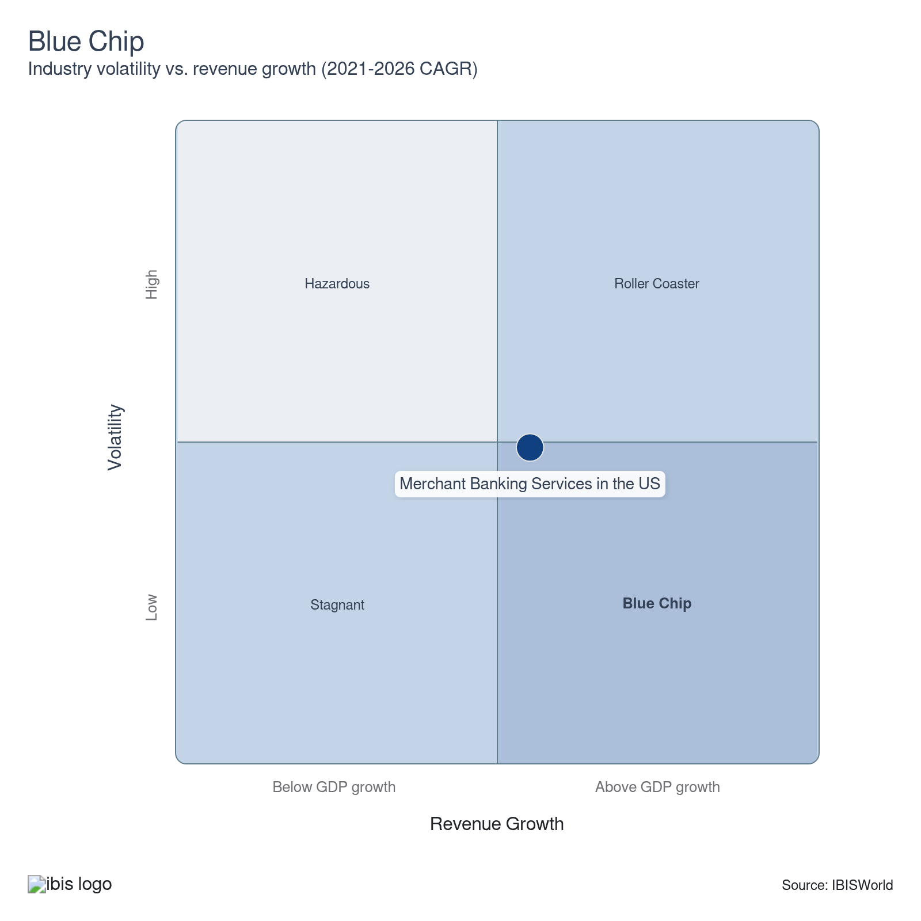

How do successful businesses overcome volatility?
Ability to effectively manage risk
Merchant banks must effectively manage risk by determining which companies to invest in and what the optimal exposure is in a given market.
Having a good reputation
Merchant banks must seem trustworthy and financially stable to attract clients and increase revenue.
Outlook | ↑ 2025-30 Revenue CAGR +1.6%

What's driving the industry outlook?

A healthy macroeconomic environment will support revenue
- Continued improvements in the macroeconomic landscape are anticipated to increase demand for foreign corporate investing, trade financing and international transaction facilitation services. The anticipated continued rate cuts at the onset of the outlook period are expected to support trade financing and industrial activity, in turn, supporting industry demand.
- Improving capital markets, rising demand for alternative assets and improving asset valuations are expected to increase the volume of private capital investments. The S&P 500 is anticipated to climb over the next five years, which will drive the volume of private capital investment into equity markets.
- A growing emphasis on middle-market private investment opportunities will boost merchant banking financing activity. In addition, revenue for the industry will be boosted as initial public offerings (IPOs) are expected to increase. Increases in IPO volumes will drive up fees from bridge financing and support industry revenue growth.
- The industry is anticipated to encounter greater demand for business loans during the outlook period. Falling interest rates at the onset of the outlook period will reduce borrowing costs, enabling businesses to increasingly borrow to fund new projects or expand operations. In addition, falling rates at the onset of the period will drive up residential real estate loans as the housing market is expected to recover.

Regulatory trends will limit expansion
- Merchant banks are often both investors and advisors, a dual role that has attracted increasing regulatory attention. Most financial services sector legislation has focused on conflicts of interest and moral hazard. Industry companies navigate these regulations by implementing robust compliance frameworks, which will increase compliance costs, raising industry expenses and hindering profit.
- According to regulators, banks that engage in proprietary trading do so solely for their benefit at the expense of their clients and push the downside risk of their investments onto taxpayers. As a result, this has garnered greater attention from regulators and will negatively affect operations for merchant banks in the coming years.
- Regulation will remain significant in the coming years within the broader financial services sector, including in this industry. Increased regulation will lead to increased employment as merchant banking services will increasingly demand employees on the compliance side. Rising industry employment will increase industry expenses and boost wages as a share of revenue.

Increased competition will put downward pressure on profit
- Profit is anticipated to decline as increased regulations will increase costs, despite the industry providing valuable capital-raising solutions outside the traditional commercial banking and public equity markets. Increasing regulations will raise industry expenses and drive growth in industry wages, cutting into industry profit.
- Mezzanine financing will continue to be a popular funding source for middle-market clients and a profitable investment proposition for merchant banks. The benefits of mezzanine financing are in its flexibility and lower cost. Higher valuations will increase the costs of equity financing relative to mezzanine financing. The S&P 500 and corporate profit are anticipated to jump, driving up company valuations and supporting demand for mezzanine financing.
- Industry participation will continue to expand despite downward pressure on industry profit. Smaller new entrants are expected to enter the industry and service their local areas and niche markets. As a result, industry establishments are expected to climb as new entrants seek to satisfy the growing demand for industry services. Although increased competition will limit revenue growth over the next five years compared to the current period.

Merchant banks will increasingly embed data analytics
- Merchant banking services will increasingly monetize proprietary deals and transaction data as packaged analytics and insight services alongside traditional advisory and financing services. High-quality data that is scarce will be significant in meeting client needs, as clients view data-driven insights as a strategic differentiator.
- Merchant banking services will enhance their digital capabilities to drive client engagement. For example, interactive portals and real-time dashboards will increasingly attract client engagement. Enhanced digital features will enhance self-service analytics and be accessible to the clients. As a result, increased accessibility to industry services and easy-to-navigate platforms will enable clients to navigate industry services and boost client satisfaction.
- Over the next five years, the industry will experience greater demand from equity investments and debt investments. Rising activity in securities brokerage, dealing and investment advice will expand the pipeline of corporations and investors requiring complex capital solutions and create cross-selling opportunities into merchant banking, such as underwriting for financial instruments, including equity and debt.
Life Cycle | Mature

Why is the industry mature?

Contribution to GDP
Merchant banking services have consistently contributed positively to US GDP. These services make business expansion, risk management and capital raising possible, ultimately contributing to economic growth. The financial services offered by merchant banks strengthen market confidence and fuel economic progress.

Market Saturation
The industry is in the mature stage of its economic life cycle, this stage is characterized by stable product segmentation and downstream markets and a direct link to growth in the overall economy. The industry does not encounter significant changes to its offerings.

Innovation
The industry is not significantly affected by technological change. Since this industry does not participate in trading and issuing securities to the public as investment banks do, developments in trading platform technology are irrelevant to the industry. As a result, innovation is limited in the industry.

Consolidation
Larger players in the US merchant banking services industry are acquiring smaller ones to achieve economies of scale and increase market share. However, the industry is mostly comprised of smaller merchant banks and during the period, the industry has encountered an influx of new players, increasing the number of industry establishments.

Technology & Systems
Technological advances in the industry primarily center on enhancing data processing and client communication. Advanced software systems assess potential investments and evaluate related risks with greater accuracy and speed. These software solutions increasingly leverage real-time analytics and automated systems to deliver data-driven insights to customers.

4. Products and Markets
https://my.ibisworld.com/us/en/industry/OD6088/products-and-markets
Largest Market  $5.5bn  Equity financing | Product Innovation  Moderate

Key Takeaways
- Merchant banks advise clients and invest alongside them. These banks have traditionally operated internationally, providing services like foreign corporate investing, trade financing and international transaction facilitation services.
- Merchant banks bridge the gap of private equity and venture capital. Their clients are generally unlisted middle-market firms seeking equity and debt financing and advisory services.

Products and Services
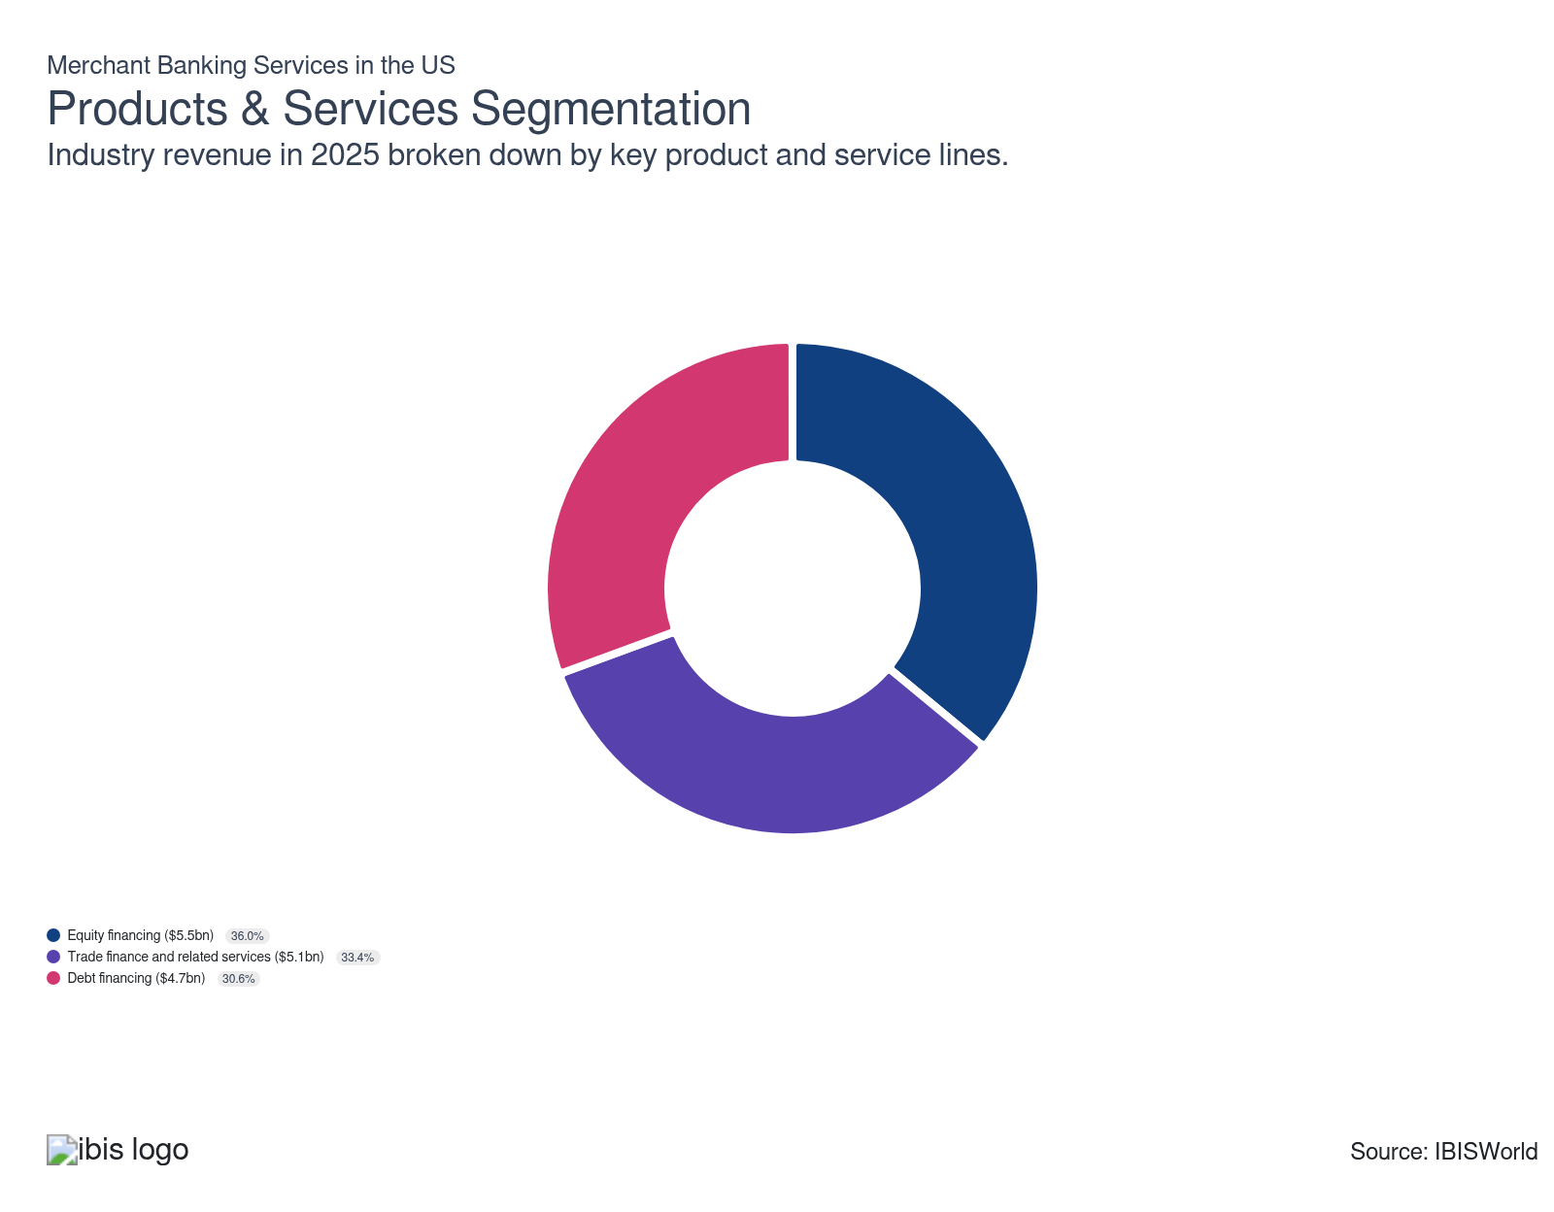

How are the industry’s products and services performing?

Equity financing lags as IPO activity slows
- In equity financing, merchant banks assist companies in raising capital by purchasing their stock. Merchant banks acquire equity in unlisted companies that require capital for business purposes. By providing this financial support, merchant banks empower businesses to achieve their objectives, develop the business and expand operations.
- Companies can use multiple equity instruments, including sales of preferred stock, convertible preferred stock, common stock and warrants. Strategically utilizing these financial instruments enables companies to optimize their capital structures and enhance their financial flexibility.
- Equity financing is used to finance the construction of infrastructure projects, such as those related to transportation and utilities. As interest rates have been cut in the latter part of the period due to easing inflationary pressures, infrastructure projects will likely increase as they become more affordable. However, equity financing decreased as IPO activity fell during the period.

Trade financing and related services swell as trade grows
- In trade finance, merchant banks reconcile the needs of exporting and importing companies. The industry provides financial solutions that facilitate international trade, ensuring smooth transactions and managing risks. Merchant banking services enhance global trade operations and strengthen economic ties.
- For a fee, merchant banks provide letters of credit and other services, like import bills for collection, shipping guarantees, import financing, performance bonds, export advising, export financing, export bills for collection, invoice financing and all document preparation.
- Trade finance has expanded to include factoring or invoice discounting, forfeiting and structured commodity finance, among other services. Trade financing has climbed because of solid import and export activities, driving the demand for sophisticated financial solutions. Although the impact of tariffs and potential trade wars may hinder trading activity and limit this segment's share of revenue.

Mezzanine financing holds up debt financing
- Merchant banks invest in various debt instruments, including bridge and mezzanine financing and credit products. In bridge financing, for example, merchant banks loan funds to companies before a more significant financing round, like an initial public offering (IPO), to cover costs associated with the IPO.
- In mezzanine financing, merchant banks invest in corporate debt to fund the expansion of the business and operations for existing companies in return for the rights to an ownership or equity interest in the company if the loan is not repaid on time and in full.
- While bridge financing has decreased because of declines in underwriting activity, higher demand and returns for mezzanine financing have raised this segment's revenue share. Mezzanine financing is popular because it provides a way for businesses to pursue growth opportunities while not giving up significant control of their business.

What are innovations in industry products and services?

Private equity firms
- Private equity firms give funds to businesses in return for equity in the company. Companies that don't want to take on debt might find this kind of financing appealing because it gives them access to resources and expertise.
- These firms can replace merchant banks by offering organizations capital and advisory services. Private equity firms with industry banks by offering similar services and offerings.

Venture capital firms
- Venture capital firms offer funding in early-stage businesses in exchange for equity in the company. Companies still in the early stages of development and require growth funding may find this financing appealing.
- Venture capital firms can provide early-stage businesses with capital and advisory services instead of merchant banks.

What products or services do successful businesses offer?
Access to highly skilled workforce
Merchant banks must have experienced employees with a knowledgeable background and sound understanding of industry services and financial markets.
Must comply with government regulations
Because merchant banks advise and invest simultaneously, operators must take care to avoid conflicts of interest and comply with strict government regulations.

Major Markets
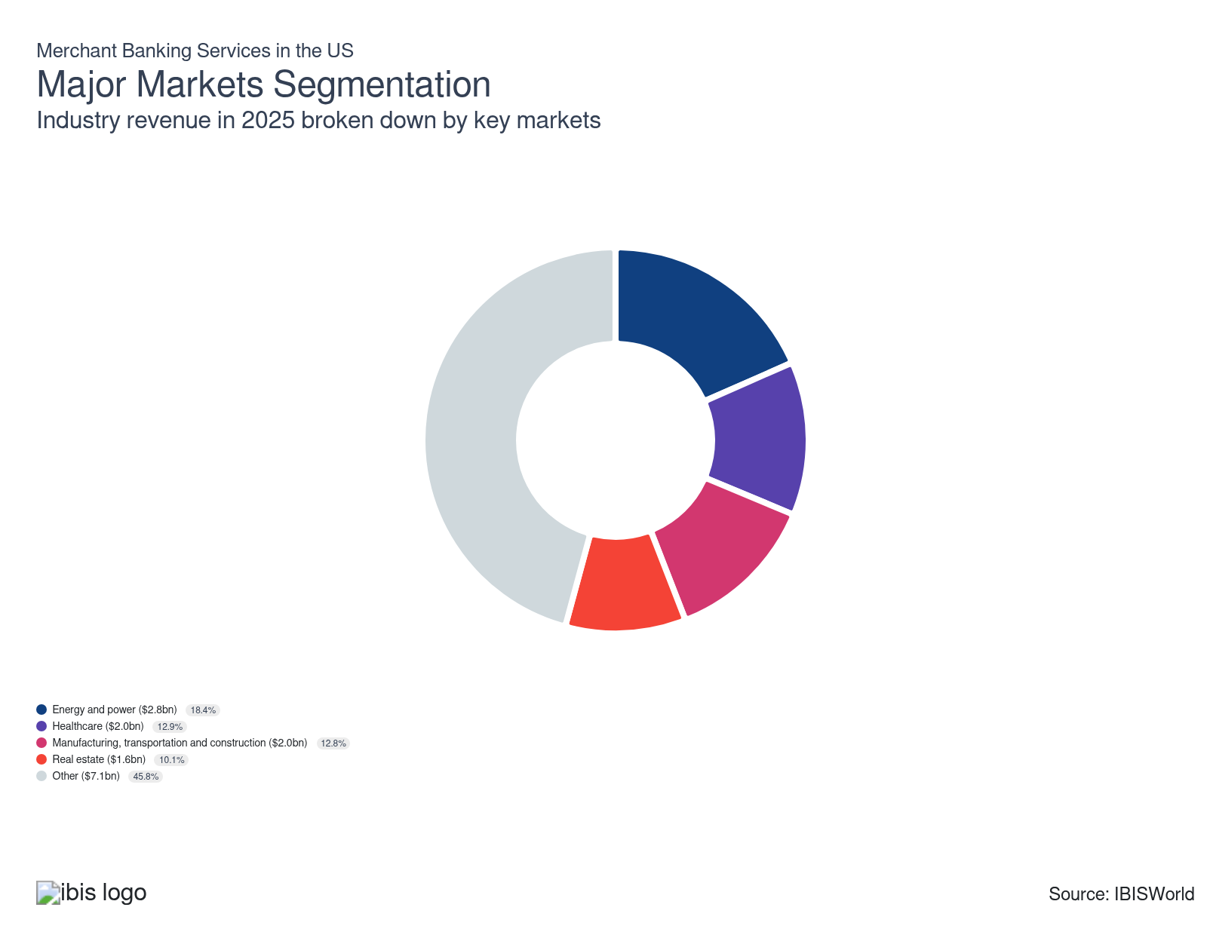

What’s influencing demand from the industry’s markets?

Demand for energy and power is elevated despite volatility
- Energy and power companies comprise a significant share of revenue and account for the single largest market for merchant banks. Clients include integrated oil and gas producers, alternative fuel suppliers, oil equipment and service providers and renewable energy equipment manufacturers, highlighting the critical role the industry plays in the energy industry's financial landscape.
- The energy and power sector experienced significant volatility and the price of oil and natural gas climbed significantly as demand picked up following sharp declines at the onset of the period. The increased demand in this market led companies to increase capacity, expanding this market segment's share of revenue.
- The energy and power market segment benefited from an increase in global productivity and demand for power during the period. However, as the economy recovered from 2020 disruptions, energy prices spiked, caused by supply chain disruptions and built-up demand. The greater demand, coupled with supply chain issues and extreme weather events in the latter part of the period, led to significant growth in the price of oil and natural gas.

Healthcare's importance in society makes it a significant market
- Companies in the healthcare sector comprise the second-largest market for merchant banks. Often, healthcare companies require large financing rounds to invest in new equipment, research facilities and other expansion efforts that necessitate significant capital expenditures.
- Because of healthcare's importance to the population, its success has a significant potential upside. The climb in the total health expenditure has driven this market's growth as private and public spending increased in the healthcare sector. In addition, the rise in adults aged 65 and older has driven this market's growth as individuals in this demographic increasingly require healthcare services.
- Merchant banking financing enables a company to be sustained through clinical trials or regulatory approval, making the healthcare sector essential for the merchant banking industry. These financial services are critical for healthcare companies, enabling them to ensure their projects reach market readiness.

Real estate swells as property values climb
- Real estate companies use merchant banking services to raise money for new developments or other projects. By leveraging financial services offered by the industry, real estate firms can efficiently raise capital, drive growth and successfully execute projects. Merchant banks are critical in advancing real estate initiatives and facilitating real estate expansion.
- Private equity investors and other funding options not always available through conventional lending channels may be accessible through merchant banks. By using merchant banks, companies can secure unique financing solutions that drive growth and innovation, highlighting the instrumental role merchant banks have in connecting businesses with tailored financial opportunities.
- Real estate clients have risen, resulting from the overall rise in property values. However, the value of residential construction has declined slightly over the past five years but the value of nonresidential construction has inched upward and has helped push the overall real estate market higher.

Manufacturing, transportation and construction rebound
- The manufacturing, transportation and construction sector includes transportation service suppliers, industrial machinery manufacturers and heavy construction contractors, among other industries. Merchant banks actively serve this market, offering tailored financial solutions, driving growth and innovation. As a result, merchant banks are critical to driving economic progress across manufacturing, transportation and construction markets.
- Despite the slow economic recovery in construction, the rebound in manufacturing and transportation increased this market's revenue share. The significant climb in manufacturing output benefited this market. Supply chain issues experienced at the onset of the period have eased, which has led to increased production and growth in manufacturing capacity.
- As interest rates climbed throughout the period, construction activity subsided and became more expensive to fund projects. However, in the latter part of the period, the Fed cut interest rates as inflationary pressures eased, which will likely increase construction activity as projects become more affordable. The Fed is expected to continue cutting rates into the onset of the outlook period, continuing to support growth in construction activity.

New technology and rising commodity prices expand opportunities
- Merchant banks also service a variety of miscellaneous markets, including retail, media, technology, consumer staples and government. Among the most significant of these industries are high technology and basic material suppliers, such as metals and chemicals manufacturers.
- The development of blockchain, artificial intelligence and machine learning technologies, increased demand from technology clients. Merchant banks provide services tailored to enable technology companies to capitalize on innovation and drive expansion in cutting-edge fields, enabling technology companies to remain competitive in a rapidly evolving market.
- Volatile commodity prices have mixed effects on the growth of materials suppliers, depending on the materials they supply. Supply chain issues and jumps in the price of semiconductors and electronic components increased volatility in this market.

International Trade

Some industries don't directly import or export goods. See reports at the manufacturing level for international trade data on relevant products.

5. Geographic Breakdown
https://my.ibisworld.com/us/en/industry/OD6088/geographic-breakdown

Key Takeaways
- Merchant banks tend to concentrate near business and financial centers. While traditionally centered in New York City, the industry has expanded in the Southeast and West, reflecting rising business activity in line with increasing incomes in these regions.
- The Great Lakes' ideal business climate attracts merchant banks. A wide range of businesses that require merchant banking services to support their plans for growth and expansion are drawn to the region because of its economic diversity.

Business Locations
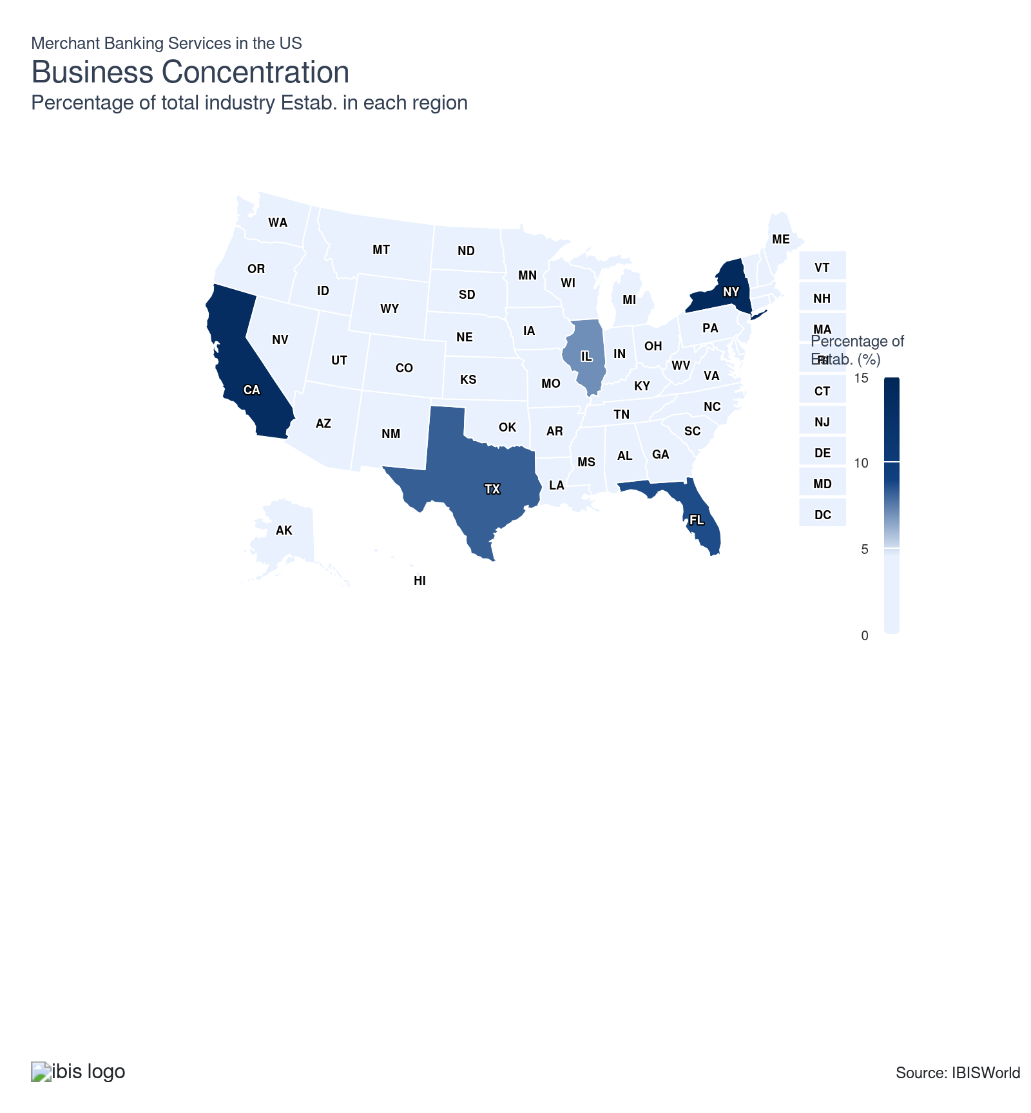
State | Estab.  Units | Estab.  % | Population  %
New York | 517 | 37.9 | 5.8
California | 496 | 36.4 | 11.5
Florida | 319 | 23.4 | 7.0
Texas | 302 | 22.1 | 9.3
Illinois | 257 | 18.8 | 3.7
New Jersey | 142 | 10.4 | 2.8
Pennsylvania | 144 | 10.6 | 3.8
Massachusetts | 125 | 9.2 | 2.1
North Carolina | 99 | 7.3 | 3.3
Ohio | 98 | 7.2 | 3.5
Colorado | 93 | 6.8 | 1.8
Georgia | 89 | 6.5 | 3.3
Virginia | 89 | 6.5 | 2.6
Connecticut | 73 | 5.4 | 1.1
Maryland | 58 | 4.3 | 1.8
Minnesota | 57 | 4.2 | 1.7
Tennessee | 53 | 3.9 | 2.1
Louisiana | 46 | 3.4 | 1.3
Michigan | 46 | 3.4 | 3.0
Washington | 48 | 3.5 | 2.3
Indiana | 43 | 3.2 | 2.0
Wisconsin | 43 | 3.2 | 1.7
Missouri | 37 | 2.7 | 1.8
Arizona | 34 | 2.5 | 2.2
Oklahoma | 29 | 2.1 | 1.2
South Carolina | 30 | 2.2 | 1.6
Delaware | 27 | 2.0 | 0.3
Oregon | 24 | 1.8 | 1.2
Alabama | 20 | 1.5 | 1.5
District of Columbia | 23 | 1.7 | 0.2
Iowa | 22 | 1.6 | 1.0
Utah | 22 | 1.6 | 1.0
Arkansas | 19 | 1.4 | 0.9
Kansas | 18 | 1.3 | 0.9
Nevada | 17 | 1.2 | 1.0
Kentucky | 13 | 1.0 | 1.3
Mississippi | 10 | 0.7 | 0.9
Nebraska | 11 | 0.8 | 0.6
South Dakota | 10 | 0.7 | 0.3
Idaho | 9 | 0.7 | 0.6
New Hampshire | 7 | 0.5 | 0.4
New Mexico | 7 | 0.5 | 0.6
West Virginia | 6 | 0.4 | 0.5
Wyoming | 6 | 0.4 | 0.2
Hawaii | 5 | 0.4 | 0.4
Maine | 4 | 0.3 | 0.4
Montana | 4 | 0.3 | 0.3
North Dakota | 4 | 0.3 | 0.2
Rhode Island | 5 | 0.4 | 0.3
Vermont | 3 | 0.2 | 0.2
Alaska | 0 | 0.0 | 0.2

Where are industry businesses located?

Mid-Atlantic is a financial hub
- The Mid-Atlantic region remains the most important geographical market for merchant banks. The region is the center of American finance, with New York, Philadelphia and Washington D.C. providing constant access to capital. Also, New York alone is home to a large portion of establishments and many establishments in New Jersey and Pennsylvania.
- The region's corporate density attracts merchant banks seeking scale and recurring engagements. The Mid-Atlantic is home to numerous Fortune 500 companies and the region sustains continuous demand for merchant banking services. Merchant banks choose to locate in this region to be near corporate headquarters, financial intermediaries and exchanges.
- Prestige and branding are also important factors, with the most prominent companies historically centered near Wall Street. A mature financial culture with generational expertise boosts the region's status as a merchant banking stronghold. Merchant banks attract clients who prioritize trust and data integrity. Also, industry operators seek skilled and talented employees from major universities to increase their competitive advantage.

The Great Lakes house the Chicago Board Options Exchange
- The Great Lakes are also an important geographical market for merchant banks. The region is historically industrial and is diverse economically, featuring advanced manufacturing, logistics and energy transition industries. Merchant banking operators concentrate in the region to provide services such as merger and acquisition advisory, debt structuring and services regarding equity investments and trade financing.
- Illinois alone is home to the largest number of industry establishments within this region. This is primarily the result of merchant banks concentrating near Chicago and the Chicago Board Options Exchange. The region attracts merchant banking operators to be in close proximity to other large financial institutions.
- This region has less expensive real estate than other financial centers like New York and San Francisco. Merchant bank services operators have diverse exposure through cross-industry financing in the region, including industrial services, logistics and renewable infrastructure. Operators develop and structure hybrid portfolios that balance stable yield projects.

Southeast and West have large populations and ideal living conditions
- Merchant banks are increasingly attracted to the Southeast region because of low tax rates. Favorable business climates and competitive regulatory structures encourage operators to locate operations in the Southeast region. Merchant banking services operators establish offices in the region to serve the expanding business environment and regional headquarters. The policy-friendly environment enables operators to structure lending instruments.
- The growing population and income levels in the region have boosted business activity. The region's accelerating urban expansion creates a continuous funding need for real estate and commercial development. Merchant banks thrive in the region by arranging complex structured financings. In addition, high migration rates feed new business formation and consumer demand.
- Merchant banks in the West region are primarily located in California, which houses many industry establishments because of the state's massive population, large corporate entities and high-tech economic centers. Having access to venture ecosystems and leading institutional investors accelerates growth-stage capital deployment.
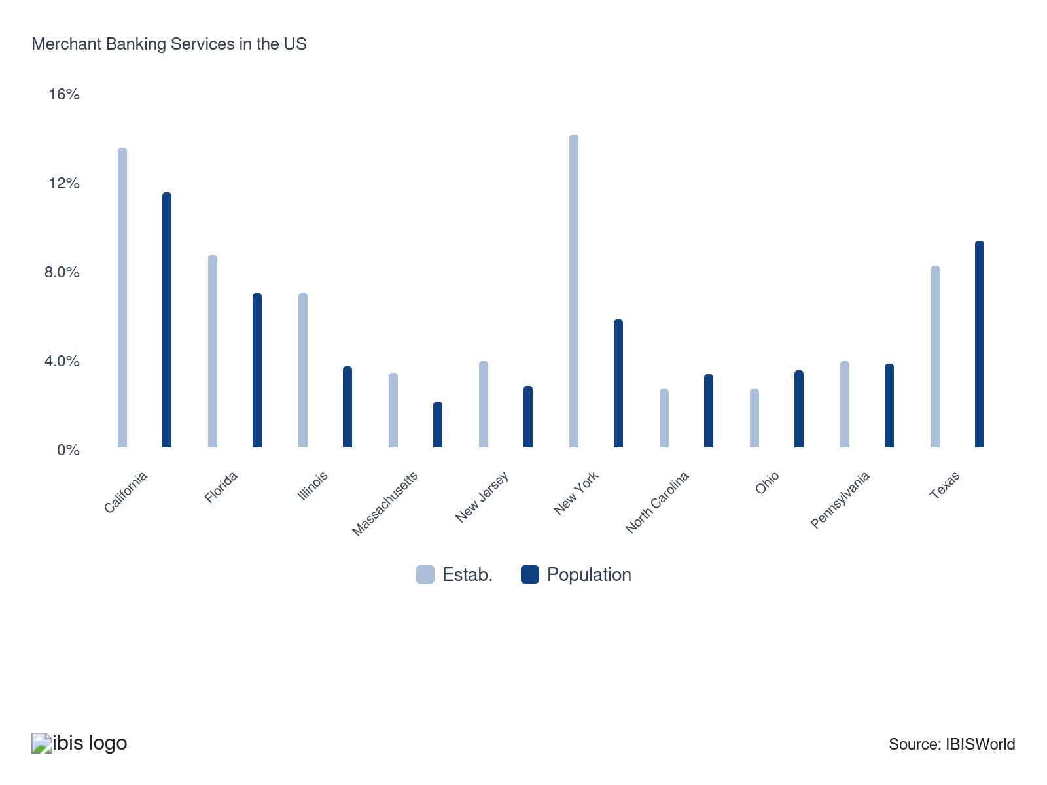

How do businesses use location to their advantage?
Operate in a location that is close to key markets
Locating in or near major financial and business centers enables operators to be in close contact with corporate clients, investors and deal flow.
Operate in states where regulations are more favorable to the industry
Choosing states with supportive financial regulations, taxes and licensing requirements enables merchant banking services to reduce compliance burdens and operating costs.

6. Competitive Forces
https://my.ibisworld.com/us/en/industry/OD6088/competitive-forces

Key Takeaways
- A good reputation goes a long way. To attract and retain clients, banking merchants must secure workers that establish trust and provide quality financial expertise.
- The competition for capital is rising. Merchant banks are better able to learn about investment opportunities and expand their investment portfolios if they have strong relationships with other financial institutions.

Concentration
Moderate
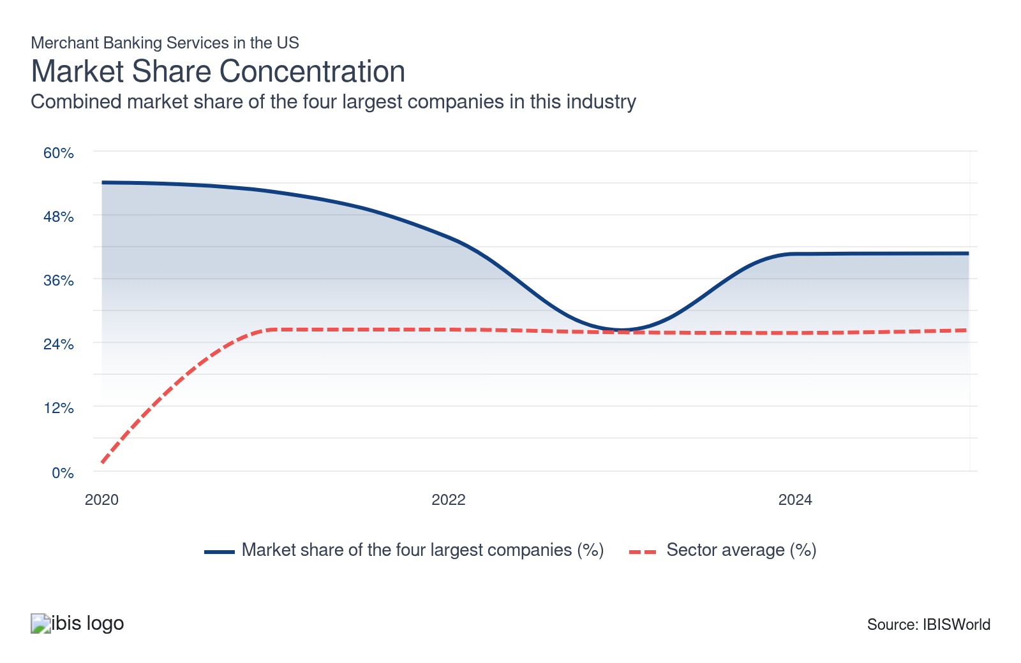

What impacts the industry’s market share concentration?

Niche markets offer opportunities for small merchant banks
- The size of the largest industry revenue generating players helps them compete with smaller players as they are able to issue more financing than other players. Beyond major operators such as JPMorgan Chase & Co. and The Goldman Sachs Group Inc., the industry is largely comprised of small, specialized operators.
- The majority of merchant banks operate on a small scale, relying on fewer than a dozen employees to invest in middle-market debt and equity opportunities or to conduct trade financing. Due to the variety of merchant banking services, new players are able to enter the industry by offering a niche service or by pursuing a particular market for investment.

The industry has grown as smaller merchant banks enter the industry
- The industry has encountered increased demand, which has led many smaller merchant banks to enter the industry. As a result, the number of industry establishments has grown as these new entrants seek to satisfy growing demand.
- The industry comprises smaller merchant banks that typically operate in specific areas or regions. The smaller players lack the economies of scale of bigger merchant banks. However, smaller banks compete with larger and established players by offering unique and specialized services.
- The industry is highly competitive and smaller niche banks service niche markets in order to remain competitive against larger players that benefit from economies of scale. The rise of industry establishments during the period limited the market share concentration of larger players.

How do successful businesses handle concentration?
Having a good reputation
Merchant banks must seem trustworthy and financially stable to attract clients and increase revenue. Smaller merchant banks offer niche and specialized services.
Have a well-defined strategy
A clear strategy enables merchant banks to focus on profitable segments, allocate capital efficiently and respond quickly to shifting credit and deal markets.

Barriers to Entry
Moderate | Increasing

What challenges do potential industry entrants face?

Legal
- The heavy regulatory environment drives up legal fees for potential entrants. Merchant banks encounter steep compliance and capital requirements that escalate legal and operational costs. Meeting these regulatory standards demands significant financial resources, discouraging smaller firms and limiting the number of new entrants.

Start-up Costs
- New merchant banks face high start-up costs and must establish reliable access to relatively cheap funding. New entrants must invest heavily in talented employees and compliance, while also building credibility in a trust-driven market. These financial and reputational demand raise start-up costs barriers.

Differentiation
- Specialization enables new entrants to effectively compete against large, established institutions by targeting numerous niche markets within the industry. Offering tailored financial services and specific expertise enables smaller firms to build distinct value propositions. Developing this specialization requires industry knowledge and strategic positioning.

Labor Expenses
- The industry is labor-intensive. Labor remains integral to banking operations, particularly in customer service, where skilled workers are required to support retail and business clients. Recruiting and retaining experienced talent drive significant operational costs for new entrants. These significant labor costs increase barriers to entry.

How can potential entrants overcome barriers to entry?
Leverage the company's business expertise
Utilizing in depth industry knowledge ensures tailored financial services, helps build client trust and enhances competitive advantages in the industry.
Develop credible and soundly based investment strategies
Creating robust strategies attracts clients, drives growth and mitigates risks by aligning investments with market dynamics and client objectives.

Substitutes
Moderate | Steady

What are substitutes for industry services?

Private Equity Firms
- Private equity firms give subsidizing to businesses in return for equity in the company. Private equity firms typically use funds from institutional investors and accredited individuals to buy equity stakes in various companies.
- Companies that don't want to take on debt might find this kind of financing appealing because it gives them access to resources and expertise. These firms can replace merchant banks in offering capital and advisory services to organizations.

Venture Capital
- Venture capital firms offer funding in early-stage businesses in exchange for equity in the business. Companies that are still in the early stages of development and require growth funding may find this kind of financing appealing.
- Venture capital firms can provide early-stage businesses with capital and advisory services in place of merchant banks. Venture capital firms can offer capital to fund various investment projects regarding equity investments.

How do successful businesses compete with substitutes?
Having a good reputation
Merchant banks must seem trustworthy and financially stable to attract clients and increase revenue.
Access to highly skilled workforce
Merchant banks must have experienced employees with a sound understanding of industry services and financial markets.

Buyer & Supplier Power
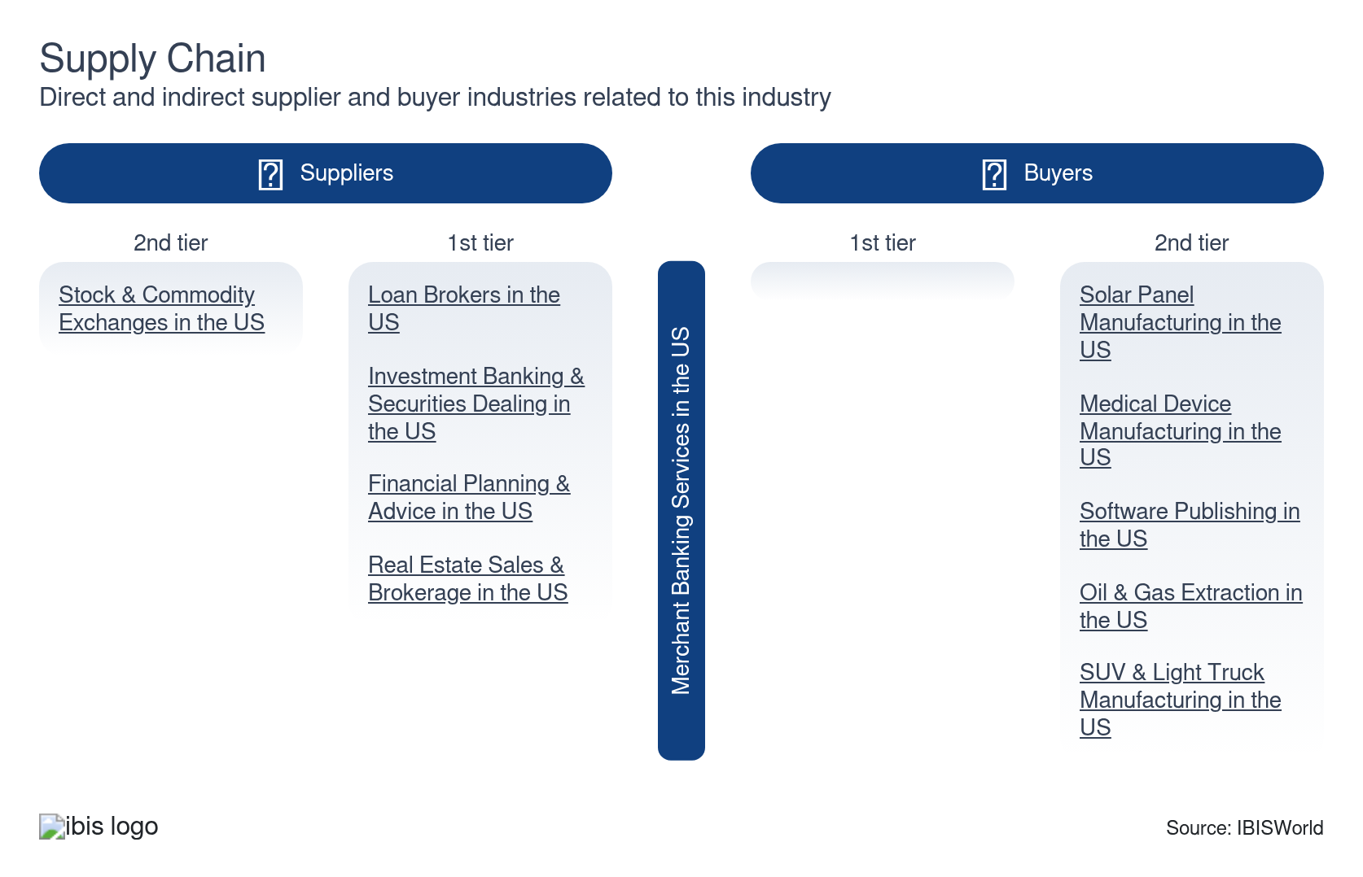

What power do buyers and suppliers have over the industry?

Buyers: Switching costs
High | Steady
- Because they have numerous choices, consumers of merchant banking services wield considerable leverage in negotiations. A buyer can easily switch merchant banks if they are dissatisfied with the terms of service one bank provides. This contributes to the competitiveness in the industry.
- Because of this, merchant banks need to provide services of high quality and competitive pricing. Having customer relationships and providing high quality service, merchant banks can retain existing clients while also attracting new customers.

Suppliers: Access to capital
Moderate | Steady
- Merchant banks need access to funding to operate efficiently and bigger banks have easier access to capital markets. Because of this, they can take on more significant transactions and offer more services to customers, giving them an advantage over smaller banks.
- In addition, larger merchant banks can operate in various areas and have greater exposure to service more customers than smaller merchant banks servicing a local area.

How do successful businesses manage buyer & supplier power?
Develop a strong market profile
Building a robust market presence attracts diverse clients and strengthens negotiating power, reducing dependency on individual buyers or suppliers.
Leverage business expertise
Utilizing deep industry knowledge and skills enables firms to offer superior services, enhancing reputation and diminishing buyer power due to fewer comparable alternatives.

7. Companies
https://my.ibisworld.com/us/en/industry/OD6088/companies

Key Takeaways
- Goldman Sachs continues to invest in consumer finance with GreenSky purchase. Goldman Sachs acquired financial technology company GreenSky for $2.3 billion in September 2021, which is a technology company facilitating home improvement loans.
- JPMorgan Chase & Co. has implemented environmental, social and governance (ESG) strategies. It has provided support to small businesses located outside of Paris and training programs for high-growth jobs in India.

Market Share
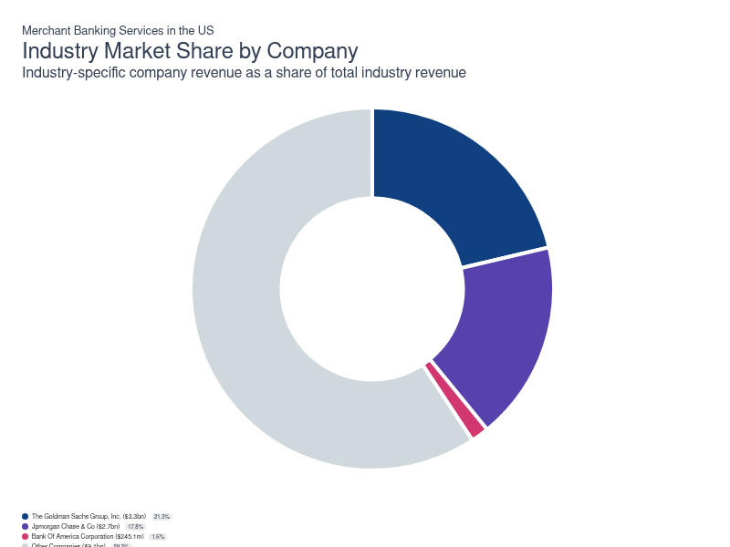
Chart displays current year only in the PDF version of this report. You can view and download chart for all other years associated with this industry on my.ibisworld.com.

Companies
Company | Market Share (%)  2025 | Revenue ($m)  2025 | Profit ($m)  2025 | Profit Margin (%)  2025
The Goldman Sachs Group, Inc. | 21.3 | 3,279.8 | 1,187.4 | 36.2
Jpmorgan Chase & Co | 17.8 | 2,740.6 | 881.3 | 32.2
Bank Of America Corporation | 1.6 | 245.1 | 68.5 | 27.9

The Goldman Sachs Group, Inc.
The Goldman Sachs Group, Inc.
Company Details
Company Details
Industry Specific Revenue (2025) | $3.3bn
Industry Profit (2025) | $1.2bn
Company Employees (2025) | 48,500
Market Share (2025) | 21.3%

Description
Description
Goldman Sachs is a public company headquartered in New York with an estimated 48,500 employees. In the US, the company has a notable market share in at least three industries: Investment Banking & Securities Intermediation, Merchant Banking Services and Private Banking Services. Their largest market share is in the Merchant Banking Services industry, where they account for an estimated 21.3% of total industry revenue and are considered an All Star because they display stronger market share, profit and revenue growth compared to their peers.

Brands and Trading Names
Brands and Trading Names
- Goldman Sachs

Other Industries
Other Industries
- Investment Banking & Securities Intermediation in the US
- Private Banking Services in the US

Company’s Industry Revenue, Market Share, and Profit Margin Over Time
Company’s Industry Revenue, Market Share, and Profit Margin Over Time
Year | Industry Revenue ($ million) | Market Share (%) | Profit Margin (%)
2020 | 2559 | 28.3 | 28.0
2021 | 2642 | 26.7 | 45.6
2022 | 1877 | 18.0 | 28.5
2023 | 772 | 5.9 | 23.2
2024 | 2981 | 20.5 | 34.4
2025 | 3280 | 21.3 | 36.2

Jpmorgan Chase & Co
Jpmorgan Chase & Co
Company Details
Company Details
Industry Specific Revenue (2025) | $2.7bn
Industry Profit (2025) | $881.3m
Company Employees (2025) | 317,233
Market Share (2025) | 17.8%

Description
Description
Jpmorgan Chase is a public company headquartered in New York with an estimated 317,233 employees. In the US, the company has a notable market share in at least five industries: Commercial Banking, Custody, Asset & Securities Services, Investment Banking & Securities Intermediation, Private Banking Services, Merchant Banking Services and Commercial Banking. Their largest market share is in the Merchant Banking Services industry, where they account for an estimated 17.8% of total industry revenue and are considered a Golden Goose because they display medium to strong market share and strong profit, but slower revenue growth than some of their peers.

Brands and Trading Names
Brands and Trading Names
- Chase Bank USA
- JPMorgan Chase Bank

Other Industries
Other Industries
- Commercial Banking in the US
- Custody, Asset & Securities Services in the US
- Investment Banking & Securities Intermediation in the US
- Private Banking Services in the US

Company’s Industry Revenue, Market Share, and Profit Margin Over Time
Company’s Industry Revenue, Market Share, and Profit Margin Over Time
Year | Industry Revenue ($ million) | Market Share (%) | Profit Margin (%)
2020 | 1597 | 17.7 | 24.3
2021 | 1887 | 19.1 | 39.7
2022 | 2158 | 20.7 | 29.3
2023 | 2408 | 18.4 | 31.3
2024 | 2703 | 18.6 | 32.9
2025 | 2741 | 17.8 | 32.2

Bank Of America Corporation
Bank Of America Corporation
Company Details
Company Details
Industry Specific Revenue (2025) | $245.1m
Industry Profit (2025) | $68.5m
Company Employees (2025) | 213,000
Market Share (2025) | 1.6%

Description
Description
Bank Of America is a public company headquartered in North Carolina with an estimated 213,000 employees. In the US, the company has a notable market share in at least six industries: Commercial Banking, Credit Card Issuing, Custody, Asset & Securities Services, Investment Banking & Securities Intermediation, Private Banking Services, Merchant Banking Services and Commercial Banking. Their largest market share is in the Private Banking Services industry, where they account for an estimated 12.8% of total industry revenue and are considered a Golden Goose because they display medium to strong market share and strong profit, but slower revenue growth than some of their peers.

Brands and Trading Names
Brands and Trading Names
- BAL energy management
- BAL Inverstment & Advisory
- Banc America Mortgage Capital
- Consumer Banking
- First Franklin Financial Corp
- General Fidelity Life insurance
- Global Wealth and Investment Management
- Merrill Edge
- Merrill Lynch
- Merrill Lynch Global Wealth Management
- Merrill Lynch Wealth Management
- US Trust

Other Industries
Other Industries
- Commercial Banking in the US
- Credit Card Issuing in the US
- Custody, Asset & Securities Services in the US
- Investment Banking & Securities Intermediation in the US
- Private Banking Services in the US

Company’s Industry Revenue, Market Share, and Profit Margin Over Time
Company’s Industry Revenue, Market Share, and Profit Margin Over Time
Year | Industry Revenue ($ million) | Market Share (%) | Profit Margin (%)
2020 | 728 | 8.1 | 20.9
2021 | 630 | 6.4 | 35.9
2022 | 510 | 4.9 | 29.0
2023 | 252 | 1.9 | 26.9
2024 | 229 | 1.6 | 26.6
2025 | 245 | 1.6 | 27.9

You can view and download company details on my.ibisworld.com.

8. External Environment
https://my.ibisworld.com/us/en/industry/OD6088/external-environment

Key Takeaways
- Most industry-specific regulation is aimed toward larger banks. Because of the financial crisis and its continuing effects, the law in the merchant banking sector is expected to continue to increase.
- The ability of banks to lend money is tracked by access to credit. An increase in credit lending indicates health in the credit markets and greater confidence of banks in their ability to be repaid on their loans and debt financing.

External Drivers

What demographic and macroeconomic factors impact the industry?
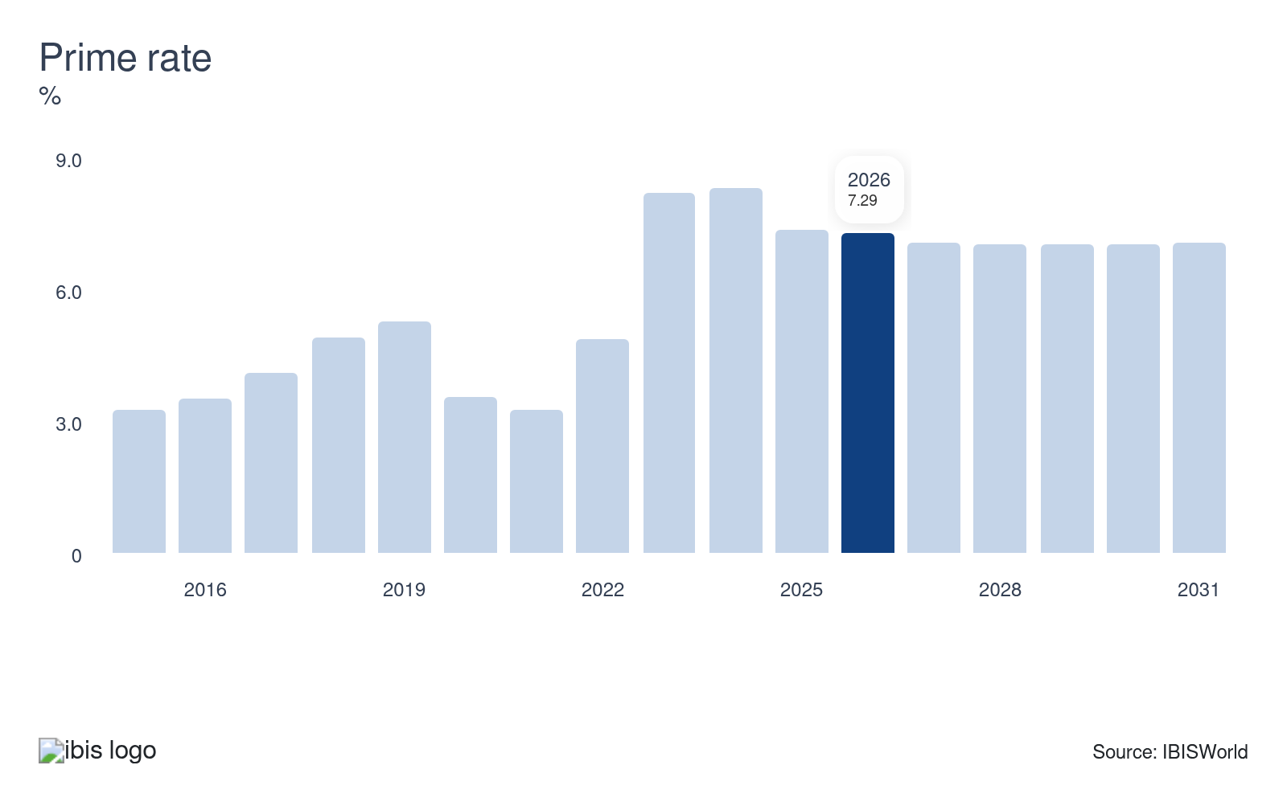
The prime rate is the interest rate charged by banks to their most creditworthy corporate borrowers. A rising prime rate is indicative of corporations’ increasing ability to service debt and is reflective of growth in the economy. For the Merchant Banking industry, an increased prime rate increases yields on debt investments in private companies, supporting industry revenue growth. Declines in the prime rate will reduce yields on debt investments, posing a potential threat to the industry.
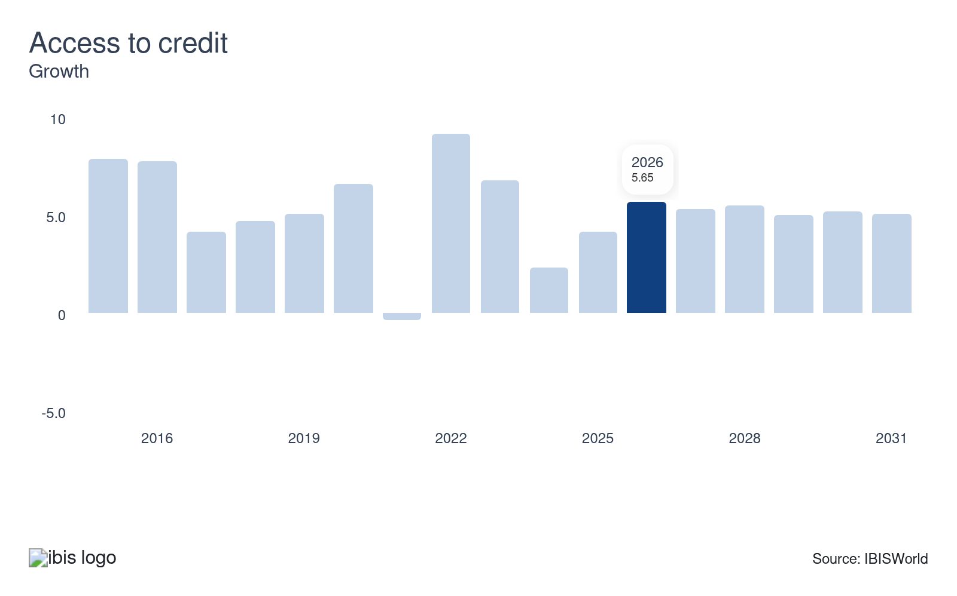
Access to credit tracks the borrowing capacity of banks to individual, corporate and institutional borrowers. As access to credit rises in the economy, the merchant banking industry is anticipated to increase trade financing and increasingly invest in the debt of private companies. Growth in access to credit represents a potential opportunity for the industry.
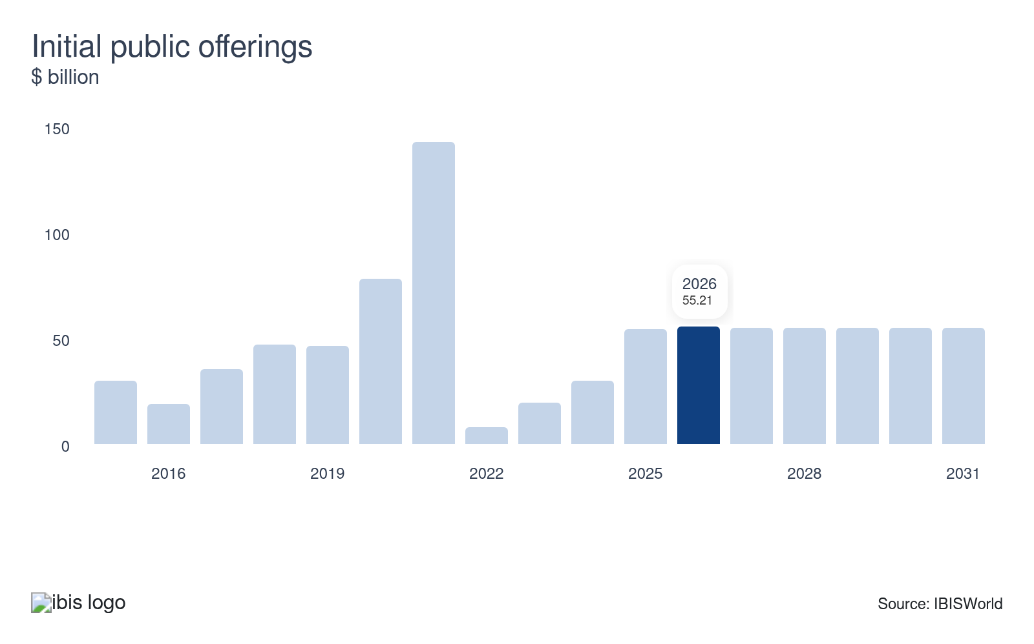
Investment banks raise investment capital on behalf of corporations that are issuing securities. While merchant banks do not directly generate revenue from IPOs, they do garner fees indirectly from bridge financing, which is short-term financing that occurs before a large financing round. Consequently, rising IPO volumes tend to benefit industry revenue. Growth in the number of IPOs will boost demand for merchant banking services.
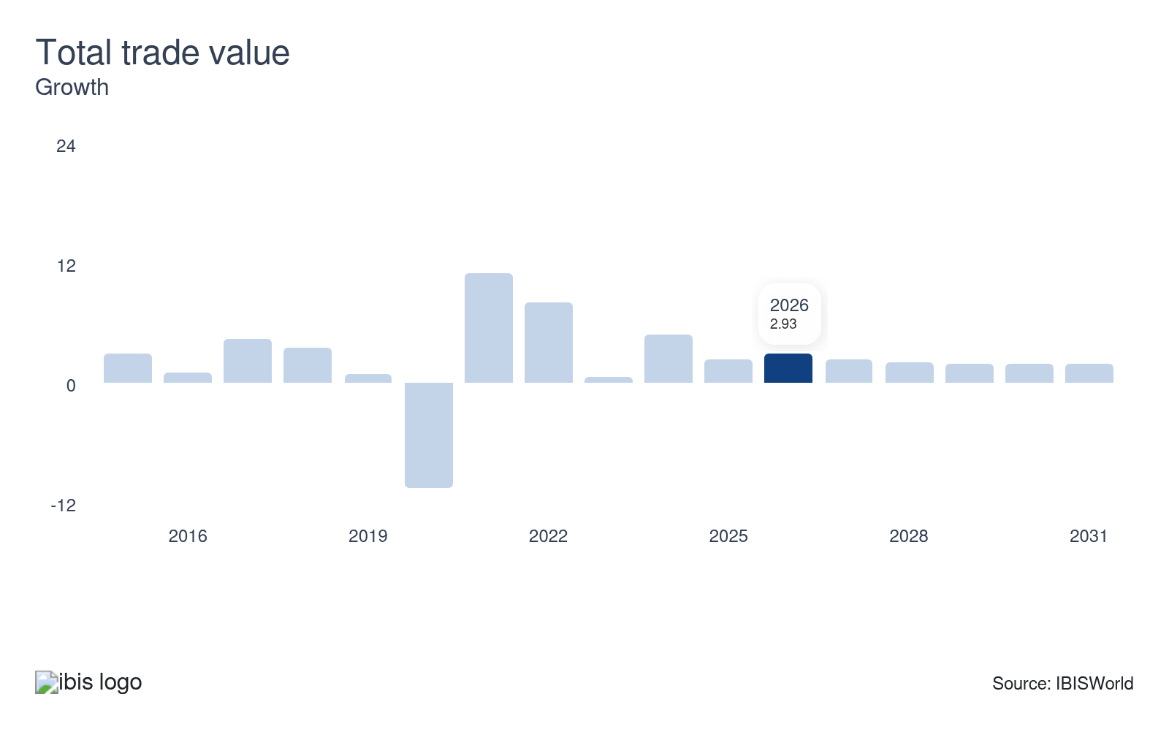
In addition to equity and debt financing, merchant banks provide foreign corporate investment, trade financing and international transaction facilitation services, among other products. Consequently, increases in the total value of trade tend to raise demand for these services. Growth in the total trade value will raise demand for industry services.

Regulation & Policy
Moderate | Increasing

What regulations impact the industry?

The Federal Reserve
Recent increases in regulation for larger banks have occurred because of their size and the potential impact they have on the broader financial system. In 2016, the Federal Reserve proposed additional regulations on merchant banking activities regarding capital requirements and physical trading commodities. These regulations have been proposed to mitigate systemic risk relating to volatility in commodity prices or a potential liquidity shortfall. By tightening controls around merchant banking activities, regulators seek to reduce the risk of liquidity shortages or disruptions caused by commodity price fluctuations.

Gramm Leach Bliley Act of 1999 (GLBA)
The primary purpose of the GLBA, more commonly known as the Financial Services Modernization Act, was to repeal some of the regulations put in place by the Glass-Steagall Act. The act is best known for knocking down the barrier between investment and commercial banks, permitting banks to expand. This act established guidelines concerning who can participate, investment time horizons and management criteria relating to merchant banks.

Volcker Rule
The Volcker Rule is a section of the Dodd-Frank Act aimed at attempting to limit risky investments made by banks with consumer deposits. Significant provisions of the Volker Rule address proprietary trading and investment in private equity and hedge funds. The Volcker Rule prohibits banks from participating in proprietary trading activities; as a result, banks affected by this rule either had to shut down operations or spin-off proprietary trading divisions.

Assistance
Low | Steady

What assistance is available to this industry?

Financial Advisory Services
Advisory services enable merchant banks in the United States to make informed decisions that positively impact the investments and financial outcomes of their clients. Market research, risk management and financial planning are just a few examples of these services. Financial advisory professionals analyze economic trends and evaluate business opportunities while designing investment strategies that align with clients' financial objectives. Merchant banks identify ventures and seek to mitigate exposure to market volatility, delivering value to customers.

Private support doesn't apply to the industry
Merchant Banking Services in the US doesn't receive any private sector support.

9. Financial Benchmarks
https://my.ibisworld.com/us/en/industry/OD6088/financial-benchmarks
Profit Margin  33.7 %  ↑ Higher than sector | Average Wage  $434k  ↑ Higher than sector | Largest Cost  Wages  45.2% of Revenue

Key Takeaways
- Profit margins widen with the introduction of new investment opportunities. The emergence of greater middle market investment opportunities and the growing popularity of mezzanine financing will support profit.
- The industry's average wage is high to reward skilled workers. Individuals with these skill sets are rare and various companies, including investment banks, compete for employment.

Cost Structure
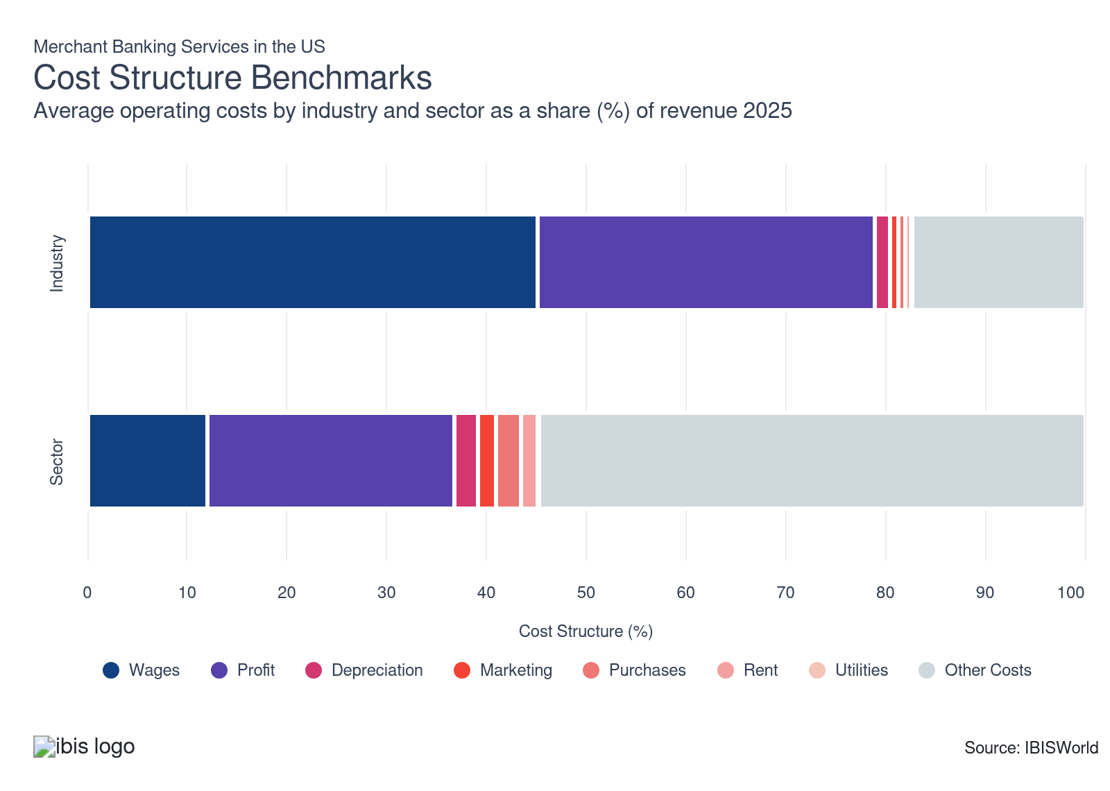
Chart displays current year only in the PDF version of this report. You can view and download chart for all other years associated with this industry on my.ibisworld.com.

What trends impact industry costs?

Wages are high to compensate workers for their skills
- Labor costs account for the most significant expense category for businesses. Labor costs include both wages, bonuses and other forms of compensation. The growth in employment and industry wages over the past five years contributed to wages as a share of revenue comprising a significant share of revenue.
- In the current year, industry wages have climbed and account for over two-fifths of industry revenue. Industry wages as a proportion of revenue climbed during the period. Companies require highly skilled employees to execute complex trade financing, equity and debt financing arrangements, as well as provide advisory services. Highly skilled employees are required to ensure competitiveness and also deliver exceptional client service in a competitive industry. Having exceptional client service can help set a smaller player apart from bigger, more established companies.

Industry profit falls despite new investment opportunities
- Industry profit has declined over the past five years but will remain significant and comprise over one-third of industry revenue in the current year. Profit varies dramatically on a product-by-product basis. Also, the increase in wage expenses has put downward pressure on industry profit.
- During the period, interest rates were elevated and limited demand for various loans. For example, vehicle loan demand and other credit intermediation services, including trust services, declined during the period, limiting industry profit.
- The industry's traditional foreign corporate investment, trade financing and international transaction facilitation services are less profitable than the bridge and mezzanine financing. The greater profit associated with bridge and mezzanine financing has driven the shift among operators to focus on these lucrative instruments.
- The industry has encountered volatile economic periods throughout the period, for example, significant inflationary pressures resulted in interest rate hikes. As inflationary pressures cooled, interest rates were slashed in the latter part of the period. In addition, rising demand for mezzanine financing services has limited the decline in industry profit over the past five years.

Major businesses define the distribution of costs
- The Merchant Banking Services industry has a moderate level of concentration, with several large companies, including JPMorgan Chase & Co. and The Goldman Sachs Group Inc. These large companies maintain significant overall industry expenses because of their significant size and scale of operations compared to smaller merchant banking services.
- These companies have significant sway over the cost structure of the industry. Significant increases in expenses for the large companies in the industry will likely increase the overall costs for the industry. In addition, significant declines in expenses for the largest companies will likely decrease the overall costs for the industry.
- Cost structures vary across the industry, as the majority of companies are small-scale operators with limited scale. Miscellaneous costs declined over the past five years.

Depreciation costs lag slightly but are minimal
- Depreciation costs have fallen slightly during the period but still comprise a small share of revenue. Depreciation costs account for expenses related to tangible assets such as buildings, furniture, IT systems and other capital equipment.
- Industry operators' operational footprints can vary based on location and size, therefore, depreciation costs fluctuate with asset size and building size. Also, merchant banking services require technological tools such as computers and telecommunication hardware, which incur higher depreciation expenses.

Marketing expenses rise slightly over the past five years
- Marketing costs are minimal, although these costs climbed slightly during the period. Marketing costs comprise both traditional marketing and digital marketing channels. Traditional marketing includes brochures, while digital marketing tools include online marketing for merchant banking services.
- Merchant banking services seek new customer acquisitions and customer retention with their marketing spend. Operators utilize marketing campaigns to reach potential customers, especially by combining targeted digital media and physical marketing to build customer relationships.

Purchase costs are relatively stable but are limited
- Merchant banking services continually require administrative and clerical supplies, such as computers and office equipment, for daily operations, including customer service. Without administrative and clerical supplies, it would be difficult for operators to meet their clients' needs.
- With the growing use of emerging technologies like AI and digital platforms, this will increasingly enable operators to protect their customers' data from cybersecurity threats and data storage devices and software will become increasingly more critical.

Rent costs lag slightly during the period
- Rent expenses for the industry comprise a small share of revenue and declined over the past five years. Rent expenses encountered downward pressure due to the rise of hybrid and remote work, which has led to companies downsizing office sizes.
- Rent costs are generally structured through long-term leases to secure stability and favorable rates. However, the size and location of office spaces can influence rent costs. For example, offices in urban centers with great visibility and large office spaces generally require higher rent expenses.

Utility costs remain relatively steady
- Utility costs are relatively steady during the period. Utility costs include electricity and heating, which are necessary for a comfortable work environment due to the need for lighting, climate control and proper telecommunications and security systems.
- Utility costs can vary depending on the location of offices and how significant the demand is for utilities. For example, large offices in urban centers will generally require greater utilities and have higher costs compared to smaller offices or offices in suburban locations.
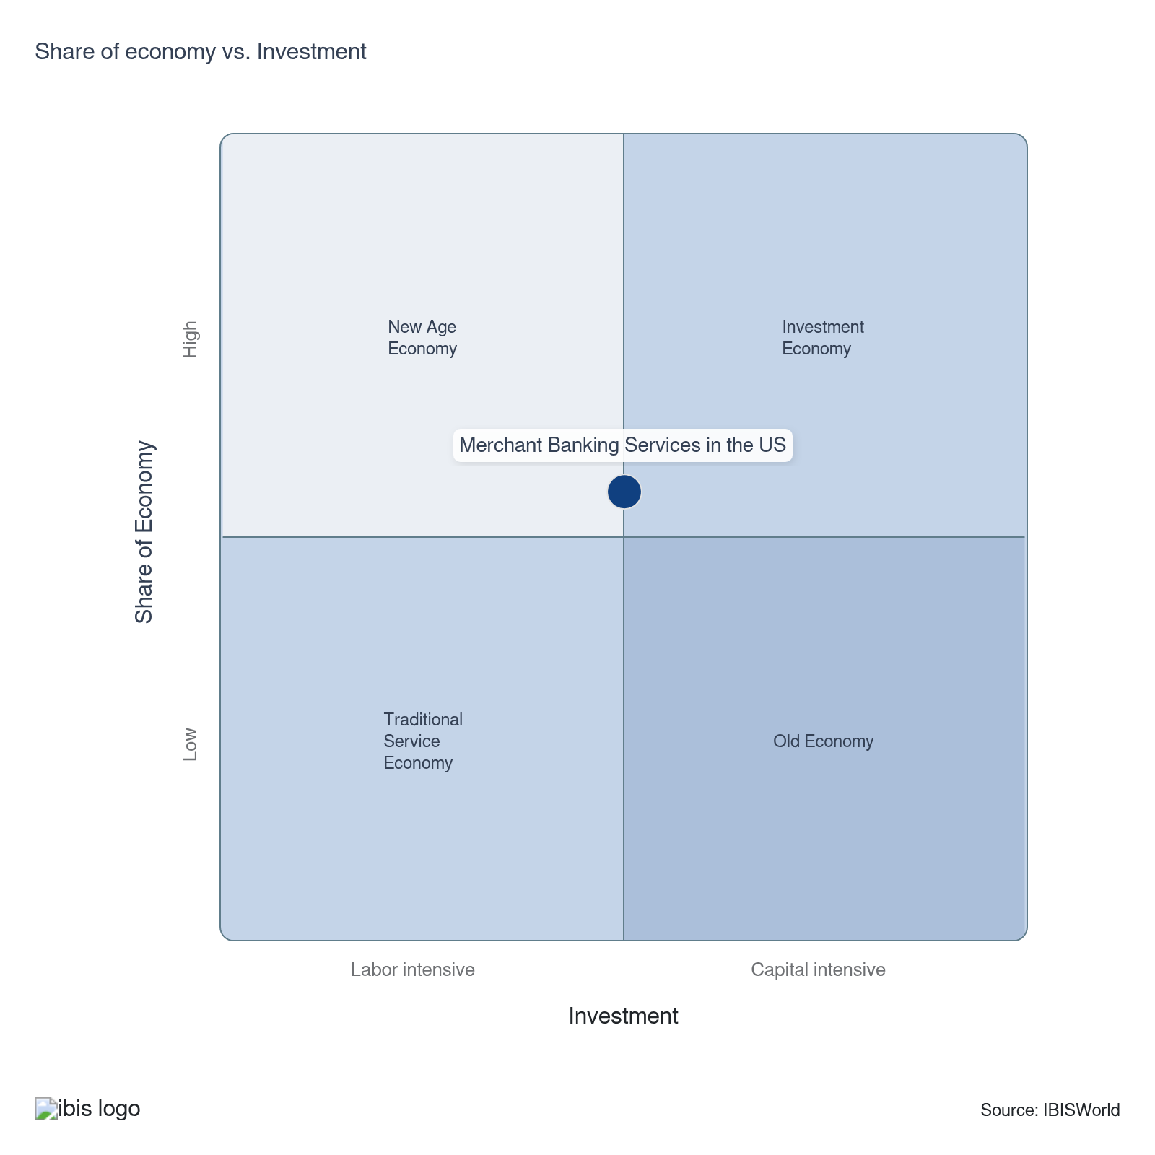

Financial Ratios

Earnings Ratios
Ratio | 2020 | 2021 | 2022 | 2023 | 2024 | 3-Year | 5-Year | 10-Year
EBIT/Revenue | 13.1 | 19.9 | 25.2 | 17.1 | 22.2 | 19.6 | 21.1 | 20.6
EBITDA/Revenue | 18.3 | 33.5 | 37.3 | 25.3 | 33.7 | 29.5 | 32.4 | 30.5
Leverage Ratio | 5.5 | 3.0 | 2.7 | 4.0 | 3.0 | 3.5 | 3.1 | 2.7

Industry Tax Structure
Ratio | 2020 | 2021 | 2022 | 2023 | 2024 | 3-Year | 5-Year | 10-Year
Taxes Paid/Revenue | 4.0 | 3.5 | 3.3 | 5.0 | 3.2 | 4.1 | 3.7 | 3.2

Income Statement
Ratio | 2020 | 2021 | 2022 | 2023 | 2024 | 3-Year | 5-Year | 10-Year
Total Revenue | 100.0 | 100.0 | 100.0 | 100.0 | 100.0 | 100.0 | 100.0 | 100.0
Business receipts | 96.0 | 90.2 | 90.4 | 65.3 | 69.6 | 67.5 | 78.9 | 87.9
Cost of goods | 0.0 | 0.0 | 0.0 | 0.0 | 0.0 | 0.0 | 0.0 | 0.0
Gross Profit | 100.0 | 100.0 | 100.0 | 100.0 | 100.0 | 100.0 | 100.0 | 100.0
Expenses
Salaries and wages | 23.0 | 16.3 | 13.5 | 11.3 | 8.0 | 9.6 | 12.3 | 15.2
Advertising | 4.8 | 4.2 | 5.1 | 3.0 | 2.0 | 2.5 | 3.6 | 3.5
Depreciation | 1.1 | 10.0 | 7.4 | 5.6 | 2.2 | 3.9 | 6.3 | 5.4
Depletion | 0.0 | 0.0 | 0.0 | 0.0 | 0.0 | 0.0 | 0.0 | 0.0
Amortization | 4.1 | 3.5 | 4.8 | 2.7 | 9.4 | 6.0 | 5.1 | 4.5
Rent paid | 4.4 | 3.3 | 2.9 | 1.9 | 1.4 | 1.6 | 2.4 | 2.9
Repairs | 0.8 | 3.5 | 2.7 | 1.1 | 0.4 | 0.7 | 1.9 | 1.7
Bad debts | 6.6 | 5.4 | 8.3 | 3.2 | 2.4 | 2.8 | 4.8 | 6.5
Employee benefit programs | 1.3 | 0.9 | 1.5 | 2.4 | 2.9 | 2.6 | 1.9 | 1.6
Compensation of officers | 0.7 | 1.8 | 0.5 | 9.7 | 9.7 | 9.7 | 5.4 | 3.5
Taxes paid | 4.0 | 3.5 | 3.3 | 5.0 | 3.2 | 4.1 | 3.7 | 3.2
Interest Income | 1.1 | 1.3 | 1.9 | 2.8 | 17.5 | 10.1 | 5.9 | 3.4
Other Income
Royalties | 0.0 | 3.0 | 0.0 | 10.8 | 3.7 | 7.3 | 4.4 | 2.0
Rent Income | 0.1 | 0.7 | 0.3 | 0.3 | 0.1 | 0.2 | 0.4 | 0.3
Net Income | 3.3 | 12.4 | 18.5 | 8.8 | 7.1 | 7.9 | 11.7 | 13.0
Charitable contributions | 0.1 | 0.0 | 0.1 | 0.0 | 0.1 | 0.1 | 0.1 | 0.1
Dividends | 0.2 | 0.4 | 0.8 | 0.8 | 1.8 | 1.3 | 0.9 | 0.6
Interest paid | 5.8 | 4.0 | 3.3 | 3.3 | 11.9 | 7.6 | 5.6 | 4.4
Net gain, noncapital assets | 0.8 | 1.0 | 2.4 | 2.4 | 0.8 | 1.6 | 1.6 | 1.1
Net long-term capital gain less net short-term loss | 0.2 | 1.5 | 0.9 | 13.9 | 4.7 | 9.3 | 5.2 | 2.5
Net loss, noncapital assets | 1.1 | 0.3 | 0.3 | 1.0 | 0.4 | 0.7 | 0.5 | 0.5
Net short-term capital gain less net long-term loss | 0.8 | 1.2 | 2.4 | 2.3 | 0.8 | 1.6 | 1.7 | 1.5
Other deductions | 38.2 | 30.2 | 27.3 | 38.7 | 36.9 | 37.8 | 33.3 | 33.0
Other receipts | 0.7 | 0.7 | 0.7 | 1.4 | 1.0 | 1.2 | 1.0 | 0.8
Pension, profit-sharing, etc., plans | 0.7 | 0.5 | 0.5 | 2.3 | 2.2 | 2.2 | 1.4 | 0.9

Balance Sheet
Ratio | 2020 | 2021 | 2022 | 2023 | 2024 | 3-Year | 5-Year | 10-Year
Assets
Cash and Equivalents | 5.2 | 8.7 | 11.3 | 9.1 | 5.8 | 7.5 | 8.7 | 7.9
Notes and accounts receivable | 19.2 | 19.3 | 18.0 | 10.2 | 5.7 | 8.0 | 13.3 | 13.9
Allowance for bad debts | 0.1 | 0.1 | 0.1 | 0.6 | 0.7 | 0.7 | 0.4 | 0.3
Inventories | 2.6 | 0.1 | 0.1 | 0.0 | 2.0 | 1.0 | 0.5 | 0.7
Other current assets | 11.1 | 11.2 | 9.8 | 7.0 | 6.1 | 6.5 | 8.5 | 11.3
Other investments | 23.8 | 16.5 | 21.4 | 25.9 | 29.4 | 27.6 | 23.3 | 20.3
Property, Plant and Equipment | 4.6 | 7.5 | 4.0 | 8.6 | 3.2 | 5.9 | 5.8 | 6.9
Accumulated depreciation | 1.7 | 0.8 | 1.7 | 4.4 | -1.9 | 1.2 | 1.3 | 1.6
Intangible assets (Amortizable) | 23.9 | 22.7 | 15.2 | 24.7 | 27.0 | 25.9 | 22.4 | 22.5
Accumulated amortization | 2.5 | 2.6 | 2.4 | 6.1 | 5.3 | 5.7 | 4.1 | 3.3
Other assets | 6.8 | 9.5 | 8.8 | 7.7 | 9.0 | 8.4 | 8.8 | 9.3
Total assets | 100.0 | 100.0 | 100.0 | 100.0 | 100.0 | 100.0 | 100.0 | 100.0
Accounts payable | 1.6 | 9.4 | 8.7 | 4.1 | 1.8 | 3.0 | 6.0 | 5.6
Liabilities and Net Worth
Mort, notes, and bonds under 1 yr | 1.3 | 1.9 | 2.2 | 4.3 | 5.9 | 5.1 | 3.6 | 3.0
Other current liabilities | 30.3 | 26.8 | 30.8 | 18.3 | 12.7 | 15.5 | 22.2 | 26.4
Loans from shareholders | 0.2 | 0.2 | 0.1 | 3.2 | 2.8 | 3.0 | 1.6 | 0.9
Mort, notes, bonds, 1 yr or more | 33.1 | 33.1 | 33.1 | 25.8 | 33.6 | 29.7 | 31.4 | 34.6
Other liabilities | 5.4 | 4.6 | 5.2 | 10.8 | 11.4 | 11.1 | 8.0 | 5.8
Total liabilities | 100.0 | 100.0 | 100.0 | 100.0 | 100.0 | 100.0 | 100.0 | 100.0
Capital stock | 15.6 | 13.7 | 9.5 | 15.4 | 6.8 | 11.1 | 11.4 | 12.5
Additional paid-in capital | 33.1 | 26.4 | 31.6 | 47.1 | 39.0 | 43.1 | 36.0 | 31.6
Retained earnings, appropriated | -4.5 | -3.1 | -4.7 | -9.9 | -4.9 | -7.4 | -5.7 | -4.3
Retained earnings-unappropriated | 7.9 | 10.6 | 8.0 | 5.4 | 13.0 | 9.2 | 9.2 | 7.5
Cost of treasury stock | 23.9 | 23.7 | 24.3 | 24.6 | 22.0 | 23.3 | 23.7 | 23.6
Net worth | 28.2 | 23.9 | 20.1 | 33.5 | 31.8 | 32.6 | 27.3 | 23.7
Accumulated depletion | 1.4 | 1.4 | 1.4 | 1.4 | 0.7 | 1.1 | 1.2 | 1.3
Depletable assets | 1.6 | 1.6 | 1.6 | 4.7 | 2.2 | 3.4 | 2.5 | 2.0
Government Obligations | 0.2 | 0.2 | 8.6 | 1.9 | 1.3 | 1.6 | 3.0 | 1.5
Land | 2.5 | 4.4 | 3.8 | 4.1 | 2.9 | 3.5 | 3.8 | 4.4
Loans to shareholders | 1.6 | 0.4 | 1.8 | 0.7 | 0.5 | 0.6 | 0.8 | 0.9
Mortgage and real estate loans | 2.4 | 2.7 | 1.0 | 6.5 | 8.9 | 7.7 | 4.8 | 4.5
Tax Exempt Securities | 0.2 | 0.2 | 0.1 | 1.3 | 0.7 | 1.0 | 0.6 | 0.4

Liquidity Ratios
Ratio | 2020 | 2021 | 2022 | 2023 | 2024 | 3-Year | 5-Year | 10-Year
Current Ratio | 1.2 | 1.0 | 1.2 | 1.1 | 1.1 | 1.1 | 1.1 | 1.0
Quick Ratio | 1.1 | 1.0 | 1.2 | 1.1 | 1.0 | 1.1 | 1.1 | 1.0
Sales/Receivables | 5.2 | 5.2 | 5.6 | 9.8 | 17.5 | 13.7 | 9.5 | 8.8
Days' Receivables | 70.0 | 70.3 | 65.7 | 37.3 | 20.8 | 29.0 | 48.5 | 50.7
Days' Inventory | N/A | N/A | N/A | N/A | N/A | N/A | N/A | N/A
Inventory Turnover | 0.0 | 0.0 | 0.0 | 0.0 | 0.0 | 0.0 | 0.0 | 0.0
Payables Turnover | 0.0 | 0.0 | 0.0 | 0.0 | 0.0 | 0.0 | 0.0 | 0.0
Days' Payables | N/A | N/A | N/A | N/A | N/A | N/A | N/A | N/A
Sales/Working Capital | 17.8 | 60.1 | 14.2 | 19.2 | 36.0 | 27.6 | 32.4 | 17.3

Coverage Ratios
Ratio | 2020 | 2021 | 2022 | 2023 | 2024 | 3-Year | 5-Year | 10-Year
Interest Coverage | 2.2 | 5.0 | 7.5 | 5.1 | 1.9 | 3.5 | 4.9 | 6.3
Debt Service Coverage Ratio | 1.4 | 2.7 | 2.3 | 1.2 | 1.5 | 1.4 | 1.9 | 4.6

Leverage Ratios
Ratio | 2020 | 2021 | 2022 | 2023 | 2024 | 3-Year | 5-Year | 10-Year
Fixed Assets/Net Worth | 1.4 | 1.7 | 1.5 | 1.6 | 1.2 | 1.4 | 1.5 | 1.9
Debt/Net Worth | 3.6 | 4.2 | 5.0 | 3.0 | 3.1 | 3.1 | 3.8 | 4.5
Tangible Net Worth | 28.2 | 23.9 | 20.1 | 33.5 | 31.8 | 32.6 | 27.3 | 23.7

Operating Ratios
Ratio | 2020 | 2021 | 2022 | 2023 | 2024 | 3-Year | 5-Year | 10-Year
Return on Net Worth, % | 46.6 | 83.4 | 125.1 | 51.0 | 69.8 | 60.4 | 82.3 | 182.5
Return on Assets, % | 13.1 | 19.9 | 25.2 | 17.1 | 22.2 | 19.6 | 21.1 | 20.6
Sales/Total Assets | 1.0 | 1.0 | 1.0 | 1.0 | 1.0 | 1.0 | 1.0 | 1.0
EBITDA/Revenue | 18.3 | 33.5 | 37.3 | 25.3 | 33.7 | 29.5 | 32.4 | 30.5
EBIT/Revenue | 13.1 | 19.9 | 25.2 | 17.1 | 22.2 | 19.6 | 21.1 | 20.6

Cash Flow & Debt Service Ratios (% of sales)
Ratio | 2020 | 2021 | 2022 | 2023 | 2024 | 3-Year | 5-Year | 10-Year
Cash from Trading | 103.3 | 94.7 | 99.5 | 96.8 | 95.7 | 96.3 | 96.7 | 96.1
Cash after Operations | 63.4 | 62.1 | 80.1 | 60.1 | 69.5 | 64.8 | 68.0 | 67.7
Net Cash after Operations | 72.3 | 64.7 | 74.3 | 68.1 | 66.5 | 67.3 | 68.4 | 69.2
Debt Service P&I Coverage | 6.3 | 7.1 | 8.9 | 7.1 | 3.5 | 5.3 | 6.6 | 8.4
Interest Coverage (Operating Cash) | 12.4 | 16.2 | 22.2 | 20.5 | 5.6 | 13.0 | 16.1 | 21.5

Key Ratios
Year | Revenue per Employee  ($) | Revenue per Enterprise  ($ Million) | Employees per Estab.  (Units) | Employees per Enterprise  (Units) | Average Wage  ($) | Wages/ Revenue  (%) | Estab. per Enterprise  (Units) | IVA/ Revenue  (%)
2003 | 1,366,006 | 38.5 | 16.0 | 28.2 | 253,018 | 18.5 | 1.8 | 40.3
2004 | 1,626,504 | 44.8 | 15.4 | 27.5 | 296,530 | 18.2 | 1.8 | 39.0
2005 | 1,671,957 | 48.3 | 17.3 | 28.9 | 316,989 | 19.0 | 1.7 | 38.2
2006 | 1,683,517 | 58.8 | 15.2 | 34.9 | 301,370 | 17.9 | 2.3 | 45.6
2007 | 1,471,254 | 60.7 | 14.0 | 41.3 | 302,308 | 20.5 | 3.0 | 52.0
2008 | 1,747,888 | 52.2 | 19.4 | 29.9 | 396,550 | 22.7 | 1.5 | 54.6
2009 | 1,394,498 | 44.8 | 17.5 | 32.1 | 294,884 | 21.1 | 1.8 | 46.6
2010 | 1,422,133 | 41.5 | 15.8 | 29.2 | 357,742 | 25.2 | 1.8 | 46.3
2011 | 1,310,767 | 38.6 | 15.6 | 29.5 | 378,365 | 28.9 | 1.9 | 53.6
2012 | 1,279,175 | 36.7 | 22.0 | 28.7 | 373,998 | 29.2 | 1.3 | 53.4
2013 | 1,244,866 | 35.7 | 18.9 | 28.7 | 342,377 | 27.5 | 1.5 | 55.1
2014 | 1,003,828 | 27.0 | 16.1 | 26.9 | 384,518 | 38.3 | 1.7 | 68.5
2015 | 799,500 | 21.6 | 18.2 | 27.1 | 371,113 | 46.4 | 1.5 | 78.1
2016 | 795,824 | 21.4 | 18.9 | 26.9 | 347,326 | 43.6 | 1.4 | 75.6
2017 | 798,238 | 21.4 | 16.7 | 26.9 | 366,320 | 45.9 | 1.6 | 76.1
2018 | 849,137 | 21.5 | 15.8 | 25.4 | 378,074 | 44.5 | 1.6 | 80.0
2019 | 880,559 | 21.6 | 15.3 | 24.5 | 380,584 | 43.2 | 1.6 | 80.2
2020 | 923,749 | 21.6 | 14.8 | 23.4 | 390,084 | 42.2 | 1.6 | 80.0
2021 | 956,069 | 22.1 | 14.1 | 23.2 | 433,840 | 45.4 | 1.6 | 80.2
2022 | 906,898 | 21.2 | 11.9 | 23.4 | 429,367 | 47.3 | 2.0 | 80.8
2023 | 953,708 | 23.1 | 12.2 | 24.2 | 433,777 | 45.5 | 2.0 | 80.5
2024 | 965,636 | 23.2 | 12.0 | 24.1 | 434,881 | 45.0 | 2.0 | 80.4
2025 | 961,091 | 22.6 | 11.7 | 23.6 | 434,484 | 45.2 | 2.0 | 80.4
2026 | 940,562 | 21.4 | 11.3 | 22.7 | 432,625 | 46.0 | 2.0 | 80.6
2027 | 936,893 | 20.9 | 11.1 | 22.3 | 432,288 | 46.1 | 2.0 | 80.7
2028 | 915,987 | 19.8 | 10.7 | 21.6 | 430,353 | 47.0 | 2.0 | 80.9
2029 | 900,267 | 18.8 | 10.4 | 20.9 | 428,879 | 47.6 | 2.0 | 81.1
2030 | 892,253 | 18.4 | 10.3 | 20.6 | 428,115 | 48.0 | 2.0 | 81.2
2031 | 882,093 | 17.8 | 10.1 | 20.2 | 427,137 | 48.4 | 2.0 | 81.3
*Figures are inflation adjusted to 2025
*Figures are inflation adjusted to 2025

10. Key Statistics
https://my.ibisworld.com/us/en/industry/OD6088/key-statistics

Industry Data

Values
Year | Revenue  ($ Million) | IVA  ($ Million) | Estab.  (Units) | Enterprises  (Units) | Employment  (Units) | Wages  ($ Million)
2003 | 21,122.5 | 8,506.7 | 969 | 549 | 15,463 | 3,912.4
2004 | 24,041.3 | 9,377.7 | 959 | 537 | 14,781 | 4,383.0
2005 | 25,848.5 | 9,882.9 | 896 | 535 | 15,460 | 4,900.6
2006 | 31,182.1 | 14,211.5 | 1,220 | 530 | 18,522 | 5,582.0
2007 | 31,103.8 | 16,173.3 | 1,512 | 512 | 21,141 | 6,391.1
2008 | 25,618.8 | 13,991.0 | 755 | 491 | 14,657 | 5,812.2
2009 | 20,595.3 | 9,596.6 | 843 | 460 | 14,769 | 4,355.1
2010 | 18,284.4 | 8,471.2 | 813 | 441 | 12,857 | 4,599.5
2011 | 16,499.9 | 8,838.4 | 809 | 427 | 12,588 | 4,762.9
2012 | 15,675.0 | 8,364.5 | 556 | 427 | 12,254 | 4,583.0
2013 | 15,575.8 | 8,582.7 | 661 | 436 | 12,512 | 4,283.8
2014 | 11,924.5 | 8,171.9 | 740 | 442 | 11,879 | 4,567.7
2015 | 9,871.4 | 7,706.5 | 678 | 456 | 12,347 | 4,582.1
2016 | 9,972.5 | 7,538.4 | 662 | 466 | 12,531 | 4,352.3
2017 | 10,203.1 | 7,768.7 | 764 | 476 | 12,782 | 4,682.3
2018 | 10,486.8 | 8,389.4 | 782 | 487 | 12,350 | 4,669.2
2019 | 10,734.9 | 8,605.1 | 795 | 498 | 12,191 | 4,639.7
2020 | 11,004.6 | 8,801.5 | 804 | 509 | 11,913 | 4,647.1
2021 | 11,513.0 | 9,236.9 | 855 | 520 | 12,042 | 5,224.3
2022 | 11,299.9 | 9,131.7 | 1,049 | 532 | 12,460 | 5,349.9
2023 | 13,700.0 | 11,024.7 | 1,181 | 593 | 14,365 | 6,231.2
2024 | 14,911.4 | 11,985.2 | 1,286 | 642 | 15,442 | 6,715.4
2025 | 15,398.6 | 12,377.1 | 1,364 | 680 | 16,022 | 6,961.3
2026 | 15,227.7 | 12,278.4 | 1,427 | 712 | 16,190 | 7,004.2
2027 | 15,947.8 | 12,863.4 | 1,530 | 762 | 17,022 | 7,358.4
2028 | 15,928.1 | 12,884.7 | 1,619 | 806 | 17,389 | 7,483.4
2029 | 16,169.7 | 13,112.5 | 1,723 | 858 | 17,961 | 7,703.1
2030 | 16,699.4 | 13,559.4 | 1,822 | 909 | 18,716 | 8,012.6
2031 | 16,896.5 | 13,743.9 | 1,901 | 950 | 19,155 | 8,181.8

*Figures are inflation adjusted to 2025

Annual Change
Year | Revenue  % | IVA  % | Estab.  % | Enterprises  % | Employment  % | Wages  %
2003 | N/A | N/A | N/A | N/A | N/A | N/A
2004 | 13.8 | 10.2 | -1.0 | -2.2 | -4.4 | 12.0
2005 | 7.5 | 5.4 | -6.6 | -0.4 | 4.6 | 11.8
2006 | 20.6 | 43.8 | 36.2 | -0.9 | 19.8 | 13.9
2007 | -0.3 | 13.8 | 23.9 | -3.4 | 14.1 | 14.5
2008 | -17.6 | -13.5 | -50.1 | -4.1 | -30.7 | -9.1
2009 | -19.6 | -31.4 | 11.7 | -6.3 | 0.8 | -25.1
2010 | -11.2 | -11.7 | -3.6 | -4.1 | -12.9 | 5.6
2011 | -9.8 | 4.3 | -0.5 | -3.2 | -2.1 | 3.6
2012 | -5.0 | -5.4 | -31.3 | 0.0 | -2.7 | -3.8
2013 | -0.6 | 2.6 | 18.9 | 2.1 | 2.1 | -6.5
2014 | -23.4 | -4.8 | 12.0 | 1.4 | -5.1 | 6.6
2015 | -17.2 | -5.7 | -8.4 | 3.2 | 3.9 | 0.3
2016 | 1.0 | -2.2 | -2.4 | 2.2 | 1.5 | -5.0
2017 | 2.3 | 3.1 | 15.4 | 2.1 | 2.0 | 7.6
2018 | 2.8 | 8.0 | 2.4 | 2.3 | -3.4 | -0.3
2019 | 2.4 | 2.6 | 1.7 | 2.3 | -1.3 | -0.6
2020 | 2.5 | 2.3 | 1.1 | 2.2 | -2.3 | 0.2
2021 | 4.6 | 4.9 | 6.3 | 2.2 | 1.1 | 12.4
2022 | -1.9 | -1.1 | 22.7 | 2.3 | 3.5 | 2.4
2023 | 21.2 | 20.7 | 12.6 | 11.5 | 15.3 | 16.5
2024 | 8.8 | 8.7 | 8.9 | 8.3 | 7.5 | 7.8
2025 | 3.3 | 3.3 | 6.1 | 5.9 | 3.8 | 3.7
2026 | -1.1 | -0.8 | 4.6 | 4.7 | 1.0 | 0.6
2027 | 4.7 | 4.8 | 7.2 | 7.0 | 5.1 | 5.1
2028 | -0.1 | 0.2 | 5.8 | 5.8 | 2.2 | 1.7
2029 | 1.5 | 1.8 | 6.4 | 6.5 | 3.3 | 2.9
2030 | 3.3 | 3.4 | 5.7 | 5.9 | 4.2 | 4.0
2031 | 1.2 | 1.4 | 4.3 | 4.5 | 2.3 | 2.1

*Figures are inflation adjusted to 2025

DISCLAIMER
This product has been supplied by IBISWorld Inc. (‘IBISWorld’) solely for use by its authorized licenses strictly in accordance with their license agreements with IBISWorld. IBISWorld makes no representation to any other person with regard to the completeness or accuracy of the data or information contained herein, and it accepts no responsibility and disclaims all liability (save for liability which cannot be lawfully disclaimed) for loss or damage whatsoever suffered or incurred by any other person resulting from the use of, or reliance upon, the data or information contained herein. Copyright in this publication is owned by IBISWorld Inc. The publication is sold on the basis that the purchaser agrees not to copy the material contained within it for other than the purchasers own purposes. In the event that the purchaser uses or quotes from the material in this publication – in papers, reports, or opinions prepared for any other person – it is agreed that it will be sourced to: IBISWorld Inc.

